

Personal Lines

Workflows & Procedures

*for*

Acrisure Mid-Atlantic Partners Insurance Services, LLC

v3.28.2025

# How to Use this Document

|  |
| --- |
| This document contains valuable information relevant to the usage of EPIC, including **Epic Basics**, day-to-day **Workflows**, and **Job Aids. DO NOT PRINT THIS DOCUMENT.**  For optimal usage:   * Click the **View** menu at the top in the Microsoft Word toolbar * Checkmark **Navigation Pane**      * The left pane will open and show a listing of topics      * Click on the topic to jump to that section/page. * Hyperlinks within the document will lead to specific pages or Job Aids.      * Some hyperlinks will connect to a webpage outside of the document. |

# Epic Browser

## Logging in

|  |
| --- |
| 1. Open a web browser.    1. Chrome    2. Edge 2. Enter URL:    1. **Production/Live**: <https://acris03.appliedepic.com/#/>    2. **Test/Training**: <https://ve061t1web.appliedepic.com/#/> |

## Add the URL as a bookmark in the Chrome or Edge Browser

|  |  |  |
| --- | --- | --- |
| 1. In the browser URL address field, enter <https://acris03.appliedepic.com/#/>; press the keyboard enter key 2. Add to Bookmarks/Favorites as follows:  |  |  | | --- | --- | | **CHROME**    Click the star icon  Enter a name for the bookmark; click Done | **EDGE**    Click the star icon  Enter name and add to Favorites Bar; click Done | |

## Browser Tabs

|  |
| --- |
| Browser tabs will open at the top when accounts are located and selected    Use browser tools like Tab Grouping and Zoom, if desired.  To prevent connection issues, close out of a client by clicking the X above the Logout button, NOT the x in the browser tab |

## Connection Suite & New Functionality Popups

|  |
| --- |
| The Connection Suite is required to ensure full functionality and connection within Epic Browser. Acrisure IT manages all updates in the background for the Connection Suite Plugin. **Ignore these popups.** If you are receiving an error, follow the instructions to hard shutdown to ensure there’s a clean connection to all services run on your computer. If you are experiencing functionality issues after shutting down, submit a ticket to [support@acrisure.com](mailto:support@acrisure.com).  ***Reminder: A hard shut down of your computer should be done at the end of each workday.*** |

## Logging out of Epic

|  |
| --- |
| **\*\*IMPORTANT\*\***  When **closing out of Epic,** click the **LOGOUT** button at the top right in the blue Options Bar. **Do not X out.** Epic will not close properly which may cause issues when signing back in again.  **NO** |

**Shutting Down Desktop**

|  |  |  |  |  |  |  |
| --- | --- | --- | --- | --- | --- | --- |
| **\*\*IMPORTANT\*\***  Log out of Epic and SHUT DOWN your computer **at the end of each workday.**   |  |  | | --- | --- | | 1. Shut down the computer by clicking the Start Menu in the bottom left-hand corner of your desktop |  | | 1. Click Power |  | | 1. Click Shut Down |  | |

# EPIC BASICS

## Epic Icons

|  |  |  |  |
| --- | --- | --- | --- |
|  | Add New |  | Change column width |
|  | Edit |  | To define a search |
|  | Print list view |  | Executes search. These are cumulative. To begin a new search, click “Clear Filter” |
|  | Sortable column – ascending/descending |  | The logout button will close all open windows. If any screen requires validation (the process isn’t complete), the screen with display prior to closing |
|  | Change the order of items | **RIGHT CLICK** | Right clicking on a selected policy, activity or contact will often generate the same menu options as found in ACTIONS. |
|  | Collapses and opens sections of screen or moves full list from one screen to another |  | Click on the Paperclip to attach documents saved in Epic (Email) |
|  | Required Field – must complete |  | Click on the File to attach files saved on a local or network drive (Email) |
|  | Desired Field – agency would like field completed |  | Contacts in EPIC (from email) |
|  | Customize columns displayed in the list view |  | Contacts in Outlook (from email) |

## Keyboard Shortcuts

|  |
| --- |
|  |

## Home Base

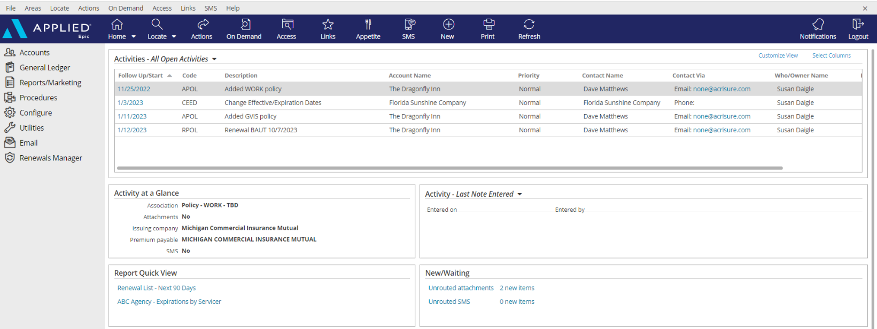

|  |
| --- |
| 1. **Open Activities** (suspense, follow up, to-do list)    * Use “**Select Columns**” to add columns to your view.    * The position of the columns can also be changed by clicking and dragging the column headers to the desired location.    * Sort columns in ascending or descending order by clicking on the column header 2. **Activity at a Glance** – displays information about the highlighted activity 3. **Activity Tasks** OR **Last Note Entered** – when a task within an activity is assigned to you, the task will appear here but only if the activity above, associated with the task, is highlighted. The view can be changed from “Activity – Tasks” to “Last Note Entered” by clicking the dropdown arrow and selecting the appropriate option. 4. **Report Quick View** – Created reports can be sent to Report Quick View for easy access. Just click the link and the report will open. Data displayed is in real time and will be refreshed as of the date it is opened 5. **New/Waiting** – If your agency has opted to use Front End Scanning, scanned mail can be accessed by clicking the “Unrouted Attachments” link. The number of items in your “inbox” will also display. 6. **Navigation Panel** – Items listed here will direct you to distinct parts of Epic or to the client’s account. Items available will change depending on which screen is being utilized. This is known as the “View” panel. 7. **Blue Options Bar** – Each icon contains action options, which will change depending on which screen is being utilized. Think of this as the “Do” bar. 8. **Log Out button** – Clicking this button will close all the open screens/windows and log out of Epic. 9. **Locate** – Click the dropdown arrow to see a list of the last 20 accounts accessed |

## Client Accounts

### Account Sources – REQUIRED FIELD

|  |  |  |  |  |  |  |  |  |  |  |  |  |  |  |  |  |  |  |  |  |  |  |  |  |  |  |  |  |  |  |  |  |
| --- | --- | --- | --- | --- | --- | --- | --- | --- | --- | --- | --- | --- | --- | --- | --- | --- | --- | --- | --- | --- | --- | --- | --- | --- | --- | --- | --- | --- | --- | --- | --- | --- |
| |  | | --- | | 0. Cross Sell-Platform | | 1. AM/AE Solicited | | 1. Producer Solicited | | 2. Referral - Acrisure Cyber Services | | 2. Referral - Acrisure Title Partner | | 2. Referral - Association | | 2. Referral - Broker - Acrisure | | 2. Referral - Broker Non-Acrisure | | 2. Referral - Carrier | | 2. Referral - Client | | 2. Referral - Employee | | 2. Referral – FBC Mortgage | | 2. Referral - Financial Partner/WM | | 2. Referral - GA | | 2. Referral - LGIT | | 2. Referral – Loan Officer | | 2. Referral – Mariner Wealth | | 2. Referral - Other | | 2. Referral – Payroll Firm | | 2. Referral - Realtor | | 2. Referral - TPA | | 3. Marketing - Acrisure.com | | 3. Marketing – Internet Search | | 3. Marketing - Other | | 3. Marketing – Social Media | | 3. Marketing - Telemarketing | | 3. Marketing - Tradeshow | | 4. Other/Unknown | | 5. Win Back | | 6. Call In/Walk In | | Z. Update Needed | | **Account Source is a Required Field.**  **Be sure to select the appropriate Source for tracking and reporting purposes.**  If the policy source is unknown,  select “**Update Needed**” to update at a later time. |

### Platform Servicing Roles

|  |  |  |  |  |  |  |  |
| --- | --- | --- | --- | --- | --- | --- | --- |
| **External Service Team** | |  | | --- | | Acrisure Service Center | | Carrier Service Center | | GA - Emerson Reid | | GA - Martin Insurance Services * | | GA - PGM * | | GA - Suvaun * |   **When an account and/or policy is managed by an external service team (the Acrisure Service Center, a Carrier Service Center, or a General Agent on the EB side), select the appropriate Service Team from the drop-down list.**  **Note:**  **An Acrisure-owned GA will be indicated with an asterisk.** |
| Marketing |
| P&C Client Advisor 1 |
| P&C Client Advisor 2 |
| P&C Servicer 1 |
| P&C Servicer 2 |
| P&C Claims |
| P&C Account Executive |
| Surety Client Advisor |
| Surety Servicer |
| EB Client Advisor 1 |
| EB Client Advisor 2 |
| EB Servicer 1 |
| EB Servicer 2 |
| EB Claims |
| Non-Insurance Product Sales |
| CRM Relationship Manager |
| Risk Consultant |
| EB Underwriter |

### Locate Account

|  |
| --- |
| * Click the **Locate** button to **search** for existing clients   **Locate Options:**   * + **Account/Business Name** – *contains full or partial account name*   + **Claims: Additional Party** – by involvement type, name, or phone number   + **Insurer Claim#** - must be exact & complete   + **Internal Claim#** - must be exact & complete   + **Date of Loss** – *range*   + **Last name, first name** – *begins with* and will search account detail name field and individual contacts   + **Lookup Code** – *begins with*   + **Phone Number** – must be exact & complete   + **Policy #** - *contains*   + **Prior Account ID** – *begins with* (from your prior system)   + **Relationship** – relationship type and then account name   + **Submission ID** – *begins with* (in marketing)   + **Vehicle Registration Number** * Click the **Locate** button to **add new** client accounts. * Click the **drop-down arrow** on the Locate button to access the last 20 accounts accessed (includes client accounts, employee accounts, company accounts, etc.) |

### Close Out of an Account Record

|  |
| --- |
| Locating and selecting an account will create a new tab in the browser. **Close the account record by clicking the X above the Logout button** NOT by clicking the x within the tab itself. |

## Contacts

|  |
| --- |
| Best Practices   * Add **each** Additional Named insured/Contact into the Contacts tab. |

### Contacts Overview

|  |  |
| --- | --- |
| **Individual Contact** | This is an additional individual contact (person) on the account. By choosing an individual contact, additional fields are made available, such as date of birth, SSN, marital status, driver's license number, etc. Click the lock to the right of the PII fields to secure the field, making it private. |
| **Primary Contact** | This is an **individual contact** that should be selected as the primary contact for the account. To make a contact **Primary,** click **ACTIONS** **> Change Primary Contact**. The Primary Contact is displayed in the Rolodex Card on the bottom left corner of the client’s account. |
| **Category** | Contacts are categorized based on their relationship to the Account: Contact Only—Policy Only—Both Contact & Policy |
| **Description** | Add **Description** to best represent the position or role of the contact (i.e., owner, manager, etc.) Select the appropriate description(s) for each Contact. This information is used for tracking and reporting. **This is a required field** |
| **Classifications** | **Be sure to select** the appropriate contact classification.  DM=Decision Maker; PC=Primary Contact   |  |  | | --- | --- | | __User - Benefits Technology | _EB Compliance | | __User - CSR24/Portal | _EB Compliance Newsletter | | __User - HR Portal | _EB Eligibility Contact | | __User - Indio | _EB HRLS Compliance Summit | | __User - Insite Portal | _EB Plan Admin | | __User - Succeed | _HR Leader | | __User - Zywave | _Personal (DM) | | __User - Zywave LMS | _Personal (PC) | | _Certificates | _Risk Management (PC) | | _Commercial (DM) | _Safety (PC) | | _Commercial (PC) | _Surety (DM) | | _Cyber (DM) | _Surety (PC) | | _Cyber (PC) | _Work Comp (DM) | | _EB (DM) | _Work Comp (PC) | | _EB (PC) | 401K Plan Administrator | |  | Acrisure Webinars | |

### Add Additional Contacts

#### Add Individual Contact

|  |
| --- |
| 1. From the client’s account, click **Contacts** in the left panel 2. Click the **ADD** button 3. Select the **Individual** radio button 4. Enter First Name, Last Name 5. **Category:** Indicate whether contact only, policy only, or both contact & policy 6. **Description:** Select the appropriate description for this contact 7. Enter the address. If the account address is the same as the contact address, check the box for Use Account Address 8. Enter phone number (indicate if mobile) and email address – 9. ***NOTE: Email is a required field***. If the contact does not have an email address, enter [none@acrisure.com](mailto:none@none.com)      1. Click **DETAIL** to add preferences and personal information such as date of birth, SSN, License Number, etc.   Click **Save Contact**. |

### Best Practice Guide for Addresses

|  |
| --- |
| ***Contact information is an important part of the Client Account record. Please follow these guidelines to keep the data clean.*** |

#### Client Addresses

|  |
| --- |
| * **First Address Line**: Enter Street address only – No Names or DBAs   + DO NOT add P.O. Box numbers; add P.O. Box information in the SECOND address line   + It is okay to include Suite Number, Apartment Number, Floor Number with the street address   A screenshot of a computer  Description automatically generated A screenshot of a computer  Description automatically generated   * + **A screen shot of a computer      Description automatically generatedA screen shot of a computer      Description automatically generatedDO NOT INCLUDE DBA NAME OR NAME OF INSURED CONTACT IN THE FIRST LINE OF THE ADDRESS FIELD. See proper instructions on adding a DBA or Contact.** * **Second Address Line:** Add P.O Box, if applicable * **Be sure to enter City, State & Zip Code** * **Address validation tools** are used in Epic Browser and in AcriVision mapping and will create errors if the street address is not shown on the first line |

## Sticky Notes

|  |
| --- |
| 1. Add a sticky note by clicking the **NEW** button in the blue Options Bar within the Client Account      1. Enter note 2. Collapse the note by clicking the double up arrows 3. Manage the Sticky Note by clicking the three vertical dots      1. Delete the Sticky Note by clicking the X 2. Add a New Sticky Note by clicking the + |

## Email

### Microsoft Outlook Integration with Epic

#### Set Outlook Email Integration Default

|  |
| --- |
| ***Setting Outlook as the Email Integration Option will allow the launch of Outlook from Epic. Emails sent from Epic will automatically attach to the client’s account and will also add a Sent Item in Outlook.***  ***This integration applies to emailing from Attachments or from any of the blue email links within a client’s account. This does NOT apply to the Distribution Manager.***   1. From the Home Base, click **Configure** from the left Navigation Panel 2. Click **User Options** and select **Email** 3. Select the Outlook radio button      1. Click **Finish.** |

### Configuring Attach to Epic Plug-In in Outlook

|  |
| --- |
| 1. Open Microsoft Outlook 2. Find **Attach to Epic** in the ribbon and click the down arrow next to the word **Applied**      1. Select Browser 2. Enter the Applied Epic Browser URL 3. Choose a Default Browser      1. X out of this window |

### Email from Distribution Manager

#### Set up Distribution Manager Email Account

|  |
| --- |
| 1. From the **Home Base**, click **Configure** from the left Navigation Panel 2. Click **User Options** and select **Distribution Email Accounts** 3. If more than one account is listed, **delete all except Primary Email Account**      1. Highlight primary Email Account and click the **Edit** pencil 2. Enter the Distribution Email Details as follows    * Associated Agency = Select from the agency dropdown list (1GL for most P&C users in the Great Lakes)    * Display Name = enter your full name    * Reply address = enter your email address 3. Click **Finish**   ***NOTE: For those whose legal entity name is being retained (Public Entity, Financial Services, etc.) it is important NOT to use the Acrisure email address; use your legal entity’s email address.*** |

#### Set up Distribution Email Signature

|  |
| --- |
| 1. From **Outlook**, Copy your email signature (Right Click/Copy or CTRL+C) 2. Go back to EPIC 3. From the **Home Base**, click **Configure** from the left Navigation Panel 4. Click **User Options** and select **Distribution Email Accounts** 5. With your DMS email account highlighted, click the edit pencil 6. Click the **Email Signature** tab 7. Click the **Add** button (+) 8. Enter a **Description** for your signature and check the **Default** box      1. In the white space below the format buttons, paste the email signature which was copied in Step 1 above (Right Click/Paste or CTRL+V) |

#### *If Acrisure Logo does not paste appropriately follow the steps below*

|  |
| --- |
| 1. Right click your Acrisure logo from your email signature inside of outlook and click Save as picture.      1. Go back into Epic, Click to Highlight box where logo should appear. 2. Select Insert/Edit Image Button 3. Search for Logo saved to your computer      1. Once Logo is selected click Open, then Click blue Ok button. 2. Resize Acrisure logo as needed. 3. Click **Finish** 4. The email signature will now be listed    Click Finish. |

#### Send Email from Distribution Manager

|  |
| --- |
| As part of the normal workflow, when the ACORD form is ready to print/send, utilize the **Distribution Manager** to send documents.   1. From the **Distribution** Tab, set delivery option to **Email** 2. The **From** field defaults to your email address, however the sender can be changed 3. Add **Signature** (should default) 4. Add more than one recipient, cc, or bcc 5. Enter body of the email with full HTML functionality (change font size/color, add logos, pictures, change alignment, etc. 6. If the documents need to be sent to multiple recipients, Click on **“To”** Button      1. Contact Address Book will open. Double click on the Contact Name to add as an additional recipient. Once all additional recipients are added, click **Finish.** |

## Faxing

### From Distribution Manager

|  |
| --- |
| As part of the normal workflow, when the ACORD form is ready to print/send, utilize **Distribution Manager** to send documents.   1. From the **Distribution** Tab, set delivery option to **email** 2. Select a “**From**” email address 3. In the “**To**” field, type [the fax number (including the 1)]**@efaxds.com** Enter **Subject** line (required) 4. Enter message, if needed      1. Click **FINISH** to send. |

## Activities

|  |
| --- |
| Activities in Epic perform three essential functions:   * Add a record to the client file to reflect an action was performed. * Allow a follow up or Open Activity serves as a reminder to do something at a current or future date * Permanently documents the file with the use of Notes within Activities   ***NOTE: Activities or Notes in an Activity cannot be moved to another account*** |

### Home Base Open Activities

|  |  |
| --- | --- |
| **Select Columns** | Check or uncheck the columns desired to reflect within the Home Base View   |
| **Customize View** | Allows the addition of other Employee activities to reflect within your own open activities list (if given permission)   |
| **Right Click to Manage** | * **Close Activity** – *follow up action is completed* * **Add Note** – *add notes related to the process which is still pending* * **Add Task** – *assign a portion of the activity process to someone else to work on* * **Change Follow-up Date/Time** – *if the deadline for completing the activity can be moved* * **Change Who/Owner** – *reassign the activity for someone else to take care of, will move selected activity to their Home Base* * **View All Notes** – *Read all notes related to a specific activity process* * **Take Ownership** – *If the activity is assigned to another person or a work group, it can be reassigned to yourself*   ***Note: multi-select activities (CTRL + Click) to apply the above actions to multiple activities at one time*** |

### Activity Access Levels

|  |  |  |  |  |  |  |
| --- | --- | --- | --- | --- | --- | --- |
| |  | | --- | | **Description** | | Accounting | | Financials | | HIPAA | | HR Consulting | | Medicare | |

### Activity Workgroups

|  |  |  |  |  |  |  |  |  |  |  |  |  |  |  |  |  |  |  |  |  |  |  |  |  |  |  |  |  |  |  |  |  |
| --- | --- | --- | --- | --- | --- | --- | --- | --- | --- | --- | --- | --- | --- | --- | --- | --- | --- | --- | --- | --- | --- | --- | --- | --- | --- | --- | --- | --- | --- | --- | --- | --- |
| |  |  | | --- | --- | | **Code** | **Description** | | @APPAY | Applied Pay Default Work Group | | @EXT | External Default Group | | @LEADS | Leads Inbox Default Work Group | | ACCT | Accounting | | APAY | Accounting - Payables | | ARVW | Accounting Review | | CERT | Certificates | | CIDT | ACRISURE Centralized Interface Download Team | | CLM | Claims | | DBSC | Direct Bill Service Center | | INVO | Invoicing | | RSP1 | ReSource Pro | | RCER | ReSource Pro Certificates | |  |  | |  |  | |

### System Generated Activity Codes

|  |  |  |
| --- | --- | --- |
| **Code** | **Description** | **Event** |
| **@APY** | Applied Pay payment received from &ContactName& | Payment from Client |
| **ACLM** | # Added claim for DOL &DateLoss& | Add Claim |
| **ADD1** | # Add Insured &AcctName& | Add Account |
| **ADD2** | # Add Prospect &AcctName& | Add Account |
| **ADDC** | # Address Applied to Other Items | Address Applied to Other Items |
| **ADSC** | # Add Service | Add Service |
| **AMMK** | # Added master marketing submission for &AcctName& | New Marketing Submission |
| **AOP** | # Add Opportunity | Add Opportunity |
| **APOL** | # Added &PolType& policy effective &PolEffDate& | Add Policy |
| **AUID** | # Issued auto ID card | Issue Auto ID Card |
| **BND1** | # Bind Policy via Master Marketing | Move Marketed Lines to Current Policies |
| **BORP** | # BOR P&C - Agent Received Date: | Add Policy |
| **CEED** | # Change Effective/Expiration Dates | Change Effective/Expiration Dates |
| **CERT** | # Issued Certificate ( &OintNm& ) | Issue Certificate |
| **CHGA** | # Audit &ServSumEffDate& &ServSumDesc& | Endorse/Revise-Existing Lines |
| **CHGE** | # Change &ServSumEffDate& &ServSumDesc& | Endorse/Revise-Existing Lines |
| **CHGI** | # Internal Correction &ServSumEffDate& &ServSumDesc& | Endorse/Revise-Existing Lines |
| **CHGL** | # &ServSumEffDate& &ServSumDesc& | Endorse/Revise-Add Line Midterm |
| **CPOL** | # Canceled - Lost Policy Eff: &ServSumEffDate& &ServSumDesc& | Cancel Policy/Line |
| **CREW** | # Canceled - Rewritten Policy Eff: &ServSumEffDate& &ServSumDesc& | Cancel Policy/Line |
| **ESIG** | # Send to eSignature | Send to eSignature |
| **EVID** | # Issued Evidence of Insurance &PolDesc& &PolEffDate& | Issue Evidence of Insurance |
| **NPQS** | # New Personal Quote Started - &PolDesc& | Generate New Quote in Epic Quotes |
| **PROP** | # Proposal Generated | Proposal |
| **RCER** | # Renewed COI | Renew Certificate of Insurance |
| **REIN** | # Reinstated policy/line | Reinstate Policy/Line |
| **RESC** | # Renew Service | Renew Service |
| **REVI** | # Renewed EOP | Renew Evidence of Insurance |
| **RPOL** | # Renewal &PolType& &PolEffDate& | Renew Policy |
| **RPQS** | # Rewrite Personal Quote Started &PolDesc& | Generate Rewrite Quote in Epic Quotes |
| **SUMM** | # Summary Generated |  |

### Manual Activity Codes (F9)

#### For Accounting Workflow Activities – See [SharePoint](https://acrisure.sharepoint.com/:w:/s/ACR-ABSAccountingTeam/ESAdZgcBwPdJt0_n5-hNILkBueeqZpQWrGK6rg54rr9l7g?e=4LVSdM&clickparams=eyJBcHBOYW1lIjoiVGVhbXMtRGVza3RvcCIsIkFwcFZlcnNpb24iOiI0OS8yMzExMzAyODcyNCJ9) for Platform Activity Guide

#### Personal Lines Manual Activities

|  |  |  |
| --- | --- | --- |
| **Code** | **Description** | **When to Create Activity** |
| **GACR** | Acrisure Real Estate Services Referral | Created by an Account Executive or Account Manager to track when a Real Estate Referral is Received |
| **GACS** | Acrisure Cyber Services Referral | Created by an Account Executive or Account Manager to track when a Cyber Services Referral is Received |
| **GAPT** | Appointment with &AcctName& | Created when an Appointment is made with a Client |
| **GCAL** | Call from &AcctName& | Created when a general call or email is received. |
| **GNRN** | Policy Not Renewed | Created to attach the notice or communication of a client policy not being renewed. |
| **GXFL** | Ex-date follow-up for &AcctName& | Created to reach out to the client in the future to win back their business |
| **PAPR** | PL - Appraisal | Created when an Appraisal is received |
| **PARV** | PL – Account Review | Created when an Account Review is initiated |
| **PBIQ** | PL - Billing Inquiry | Created when a Billing Inquiry is received |
| **PBND** | PL Bind Request to Carrier | Created when a Bind Request is to be sent to the carrier. |
| **PCIQ** | Coverage Inquiry | Created when a Coverage inquiry is received from the client or an additional interest. |
| **PCN1** | PL - Carrier Notice of Cancellation | Created when a carrier notice of cancellation (NOC) is received. |
| **PCN2** | PL - Notice of Cancellation for Non-Payment | Created when a notice of cancellation (NOC) for non-payment is received. |
| **PCRF** | PL - Refer Claim to Claims Team | Created when a Claim is referred to our Internal Claims Team |
| **PEOP** | PL - EOP Request | Created when an Evidence of Property is Requested from our client or an additional interest. |
| **PLCR** | PL - Loss Control Recommendation | Created when a Loss Control Program is created for the client. |
| **PLRR** | PL – Renewal Review | Created when reviewing an upcoming renewal policy to be sure the incumbent is still the best fit. |
| **PMVR** | PL - MVR Request | Created when we receive an MVR Request. |
| **PNCO** | New PL Client Onboarding | Created when we are Onboarding a New Client to our Agency |
| **PRSK** | Account At Risk | Created for review of an Account at Risk. |
| **QNEW** | Quote - New Business | Created for documentation during the new business quoting process |
| **QREW** | Quote – Renewal/Rewrite | Created for documentation during the rewrite quoting process |

## Attachments

### Attachment Naming Conventions

|  |
| --- |
| The Platform naming convention protocol is to start the description with the term (an example: 2024 to 2025 would be 24-25) then the line of business/policy type, followed by a description of the attachment. The table below provides examples for many attachment types. A spreadsheet with more details can be found on the Mid-Atlantic SharePoint page in the Epic Resources folder.  *If an attachment is received into Epic via eDoc interface, the attachment description should be renamed to match the naming convention and the attachment associated with the applicable open activity, either a Zcode for policy detail download or the user created activity pending receipt of document from carrier (ex: CHGE, APOL, CPOL, RPOL, ZREN).*  The naming convention applies to attachments, not activity description or policy descriptions |

|  |  |  |
| --- | --- | --- |
| **Document** | **Naming Convention** | **Example** |
| Applications, not generated in Epic | YY-YY (Term) Line of Business (ex. General Liability, Homeowner, Notary Bond) Application (type of App) Carrier (if supplemental) signed /not signed | 23-24 D&O Supplemental App Chubb not signed |
| Schedule | YY-YY (Line of Business) Schedule description | 23-24 Commercial Auto Vehicle Schedule; 23-24 Commercial Property BPP Schedule loc 3 |
| Statement of values | YY-YY (Line of Business) Statement of Value | 23-24 Commercial Property Statement of Value |
| Submission to Carrier | YY-YY (Line of Business(es)) submission to (carrier/underwriter/broker description) | 23-24 Commercial Auto, Umbrella, General Liability submission to Mike @ Travelers |
| Quotes | YY-YY (Line of Business) Quote (Carrier) $Premium | 23-24 Homeowner Quote Safeco $2000 |
| Bind Order from Client email | YY-YY (Line of Business) (Carrier/Broker) bind order from client eff date | 23-24 Homeowner Safeco Bind order from insured eff 09/15/23 |
| Bind Order to Carrier/Broker | YY-YY (Line of Business) bind order to (carrier/broker) eff date | 23-24 Comm Auto Bind order to Hanover eff 10/01/23 |
| Bind Confirmation from Carrier/Broker | YY-YY (Line of Business) bind confirmation from (carrier/broker) | 23-24 Commercial Auto Bind confirmation from Hanover |
| Binder from Carrier | YY-YY (Line of Business) Binder (Carrier/Broker) eff date | 23-24 Personal Auto Liberty Mutual Binder eff 11/15/23 |
| Policy | YY-YY (Line of Business) Policy (carrier) eff date Premium | 23-24 Comm Package Policy Travelers eff 2/1/2024 $2500 |
| Audit | YY-YY (Line of Business) Audit (carrier) eff date Premium Change | 23-24 Work Comp Audit Travelers eff 11/04/23 $250RP |
| Email request for Certificate or Evidence | YY-YY Certificate Request for (holder name/project name, etc.) | 23-24 Cert request for City of Newark Project #1234 |
| Change Request email from insured | YY-YY (Line of Business(es)) From insured, (describe change request) eff date | 23-24 Personal Auto request from insured incr Coll ded to $500 eff 2-14-2024 |
| Change Request to Carrier/Broker | YY-YY (Line of Business) change request to (Carrier) describe change, eff date | 23-24 Personal Auto change request to Travelers, add 2023 Ford Escape VIN #12345 eff 12/15/23 |
| **Document** | **Naming Convention** | **Example** |
| Endorsement | YY-YY (Line of Business) Endt # | 24-25 Commercial Auto Endt #3 add 2024 Dodge Ram #98653 eff 2/15/2024 $500AP |
| Cancellation Request from Client | YY-YY (Line of Business) cancellation request from insured eff date | 23-24 Personal Auto cancellation request from insured eff 11.16.2023 |
| Cancellation Request to Carrier/Broker | YY-YY (Line of Business) cancellation request to (carrier) (eff date of canc) | 23-24 Personal Auto signed LPR to Safeco eff 11/16/2023 |
| Cancellation Endorsement (other than for Non-Pay) | YY-YY (Line of Business) Cancellation eff date, reason | 23-24 CAU1 Cancellation eff 9/23/2023 Insured request Sold Property |
| Notice of Intent to Cancel for Non-Payment and/or Cancel for Non-Pay Endorsement | YY-YY (Line of Business) Intent to Cancel for NonPay eff date $amount due | 23-24 Work Comp Intent to Cancel NonPay eff 1/25/24 $500 due |
| Notice of Non-Renewal | YY-YY (Line of Business) Notice of Non-renewal, reason | 23-24 Commercial Property Notice of Non-renewal, Claims |
| Reinstatement | YY-YY (Line of Business) Reinstatement eff date | 23-24 Personal Auto Reinstatement eff 2/14/2024 |
| Carrier/Broker Invoice for Agency Bill | YY-YY (Line of Business) Carrier/Broker Invoice eff date | 23-24 Cyber Broker Invoice eff 10/01/2023 |
| Claim details from insured via email | DOL (date of loss) Claim details | DOL 12/15/23 General Liab Travelers Customer trip and fall details from manager |
| Claim Emails | DOL (date of loss) (enter description of email) | DOL 12/25/23 email to insd - adjuster will provide details |
| Police Report | DOL (date of loss) Police Report | DOL 11/15/23 Police report |
| Adjuster notes/Status updates | DOL (date of Loss) Adjuster notes or Status Update | DOL 11/15/23 Adjuster Notes; DOL 12/15/23 Claim Status |
| Claim Notices from Carrier | DOL (date of loss) Claim Notice Carrier Claim number if known | DOL 11/15/23 Claim Notice # 123456 |
| Claim Photos | DOL (Date of Loss) Photos | DOL 11/15/23 Photos |
| Suit Papers | DOL (date of loss) Suit Papers | DOL 9/15/23 Suit Papers |
| Appraisal - building/real estate | YY-YY (Line of Business) Appraisal loc description | 24-25 Homeowner Appraisal Loc 1 123 Main St |
| Appraisal - Jewelry/Fine Arts/Antique Auto (used for agreed value) | YY-YY (Line of Business) Appraisal description of item | 23-24 Homeowner Appraisal Diamond Engagement Ring |
| Inspections | YY-YY (Line of Business) inspection | 23-24 Comm Property Inspection report from Carrier |
| Loss Control Report/Risk Management Documents | YY-YY (Line of Business) (loss control report/risk control document) describe | 23-24 Work Comp Loss Control Report site visit 10/20/2023 |
| Emails to/from UW/Client/Team | YY-YY (Line of Business) description of email | 24-25 General Liability email to UW reg exposure exclusion |

### Attach using Add Attachment Button located in Attachment area:

|  |
| --- |
| 1. Click the **ADD** Button (+)    1. Select **Existing File** (from outside of Epic (i.e., local or network drive))    2. Select **Document** to access the Form Letter library    3. Select **eForm** to add a form filler ACORD form from the eForms library   ***Note:*** *when creating initial activity, it is best practice to associate activity to the policy level. If there is no policy when activity is created, associate activity to Account level.* |

### Adding Attachments and Documents by Dragging and Dropping into Epic

|  |
| --- |
| 1. Drag & Drop from Outlook, Network folder or Desktop into Epic 2. Attach all documentation to the corresponding **ACTIVITY**     Update the description using the Platform Naming Convention  Use this feature to quickly find important documents such as policy dec pages, endorsements, etc.  Check the client accessible box to make an attachment available in the client portal (CR24).  ***Note:*** *when creating initial activity, it is best practice to associate activity to the policy level. If there is no policy when activity is created, associate activity to Account level* |

### Add Attachments and Documents using Attach to Epic Plug–In

|  |
| --- |
| **Attaching New Email Using Attach to Epic Plug-In**   1. Click **NEW Email** Button in Outlook 2. Checkbox Attach to Epic Box 3. Add Client Email Address in the To Field, Type Title in Subject Line and Type out body of email. When finished with email and all relevant documents are attached, click **SEND**. 4. Attach To Tab will open in Browser 5. Click Magnifying Glass to the right of the Code Field to Locate Client. Click **Finish** Once Account is found. 6. Under Attach To – Identify and attach the Email and/or documents to the Activity Level. 7. Once all required fields are completed, Click **Finish** and email will be routed into Applied.   **Attaching Existing Email Using Attach to Epic Plug-In**   1. Right Click on existing email in Outlook and select Attach to Epic 2. Attach to Tab will open in Browser 3. Click Magnifying Glass to the right of the Code Field to Locate Client. Click **Finish** Once Account is found. 4. Under Attach To – Identify and attach the Email and/or documents to the Activity Level. 5. Update the description box to reflect the Platform Naming Convention 6. Once all required fields are completed, Click **Finish** and email will be routed into Applied. |

### Managing Unrouted Attachments

|  |
| --- |
| Documents that arrive via USPS and are scanned in at a central location, will be placed in the servicers Unrouted Attachments. Unrouted Attachments are located in the New/Waiting area on the Home Base and functions as an electronic Inbox. Servicers should review their Unrouted Attachments every day by clicking on the link.  A screenshot of a computer  Description automatically generated  Unrouted attachments are listed in the Inbox area to the left of the screen and there is a Preview pane on the right. To preview each document, select an item. Double click the selected document to open in a read only mode.  A screenshot of a computer  Description automatically generated  Documents in Unrouted Attachments are to be assigned to the appropriate account/activity/policy line using the following steps:  Highlight/Select the attachment you want to manage, Click **Actions** (or right click on attachment)  Select from the Dropdown  **A screenshot of a computer  Description automatically generated**   1. **Attach Image –**  * A screenshot of a computer    Description automatically generatedAttach to Client; Select Lookup Code * Account Lookup by Account Name Contains * Attach to Account, Activity, Policy, Claim * A screenshot of a computer    Description automatically generatedUpdate Description of Attachment to the platform Naming Convention  1. A screenshot of a computer     Description automatically generated**Edit Details –** Edit the description of the scanned item 2. **Reassign** to Other Employee  * Search where **Account Name Contains** enter first or last name * Click Find * Select Employee * Click Finish   A screenshot of a computer  Description automatically generated   1. **Recycle** to delete unrouted attachment 2. **Save to Downloads Folder** to save unrouted attachment to your Downloads folder file on your computer  * This allows you to drag and drop from Downloads folder file into activity if needed. |

### Attachment Access Levels

|  |  |  |  |  |  |  |  |  |  |  |  |  |  |  |
| --- | --- | --- | --- | --- | --- | --- | --- | --- | --- | --- | --- | --- | --- | --- |
| Access levels allow restriction of access to attachments by granting security rights to certain groups.  The default Access Level = Public and is the one that will be used for most P&C business   |  |  | | --- | --- | | **Access Level** | **Description** | | 1 | HIPAA | | 2 | Accounting | | 3 | Financial Services | | 4 | Client Financials | | 5 | HR Consulting | | 6 | Medicare | |

### Attachment Actions

|  |  |
| --- | --- |
| Click **ACTIONS**   | * **Convert to PDF** – *Converts any document to PDF format in two clicks; can also combine multiple documents into one PDF document* * **Distribute Attachments** – *Uses Distribution Manager to email documents to client contacts* * **Edit Attachment Detail** – *Edit description, association, access levels, and folder* * **Move Attachment** – *Move attachment to another account, folder, etc.* * Policy Checking (Do Not Use) * **Reactivate Attachment** – *Used to remove an attachment from the Inactive area* * **Send via CSIO eDelivery –** NOT APPLICABLE * **Send to eSignature** – *Launches DocuSign* * **Send Via Email** – *Emails attachment through Outlook* |

***PLEASE FOLLOW THE ATTACHMENT NAMING CONVENTION PROTOCOL.***

### Finding and Viewing Attachments/Documents

|  |
| --- |
| * **Important Policy Documents:** In the attachments list view, click the link “Show Only Important Policy Documents” to view all documents being previously marked as “Important”   To revert to all documents, click “Show All Documents.” This link serves as a filtering tool.     * **Filters:** Choose a filter: Ex. Attached within last 6 months.     Filtering by multiple Types of Business is also an option and can be set as the filter default  A screenshot of a computer  Description automatically generated |

### Platform Folder Structure

|  |  |  |  |  |  |  |  |  |  |  |  |  |  |  |  |  |  |  |  |  |  |  |  |  |  |  |  |  |  |  |  |  |  |  |  |  |  |  |  |  |  |  |  |  |  |  |  |  |  |  |  |  |  |  |  |  |  |  |  |  |  |  |  |  |  |  |  |  |  |  |  |  |  |  |  |  |  |  |  |  |  |  |  |  |  |  |  |  |  |  |  |  |  |  |  |  |  |  |  |  |  |  |  |  |  |  |  |  |  |  |  |  |  |  |  |  |  |  |  |  |  |  |  |  |  |  |  |  |  |  |  |  |  |  |  |  |  |  |  |  |
| --- | --- | --- | --- | --- | --- | --- | --- | --- | --- | --- | --- | --- | --- | --- | --- | --- | --- | --- | --- | --- | --- | --- | --- | --- | --- | --- | --- | --- | --- | --- | --- | --- | --- | --- | --- | --- | --- | --- | --- | --- | --- | --- | --- | --- | --- | --- | --- | --- | --- | --- | --- | --- | --- | --- | --- | --- | --- | --- | --- | --- | --- | --- | --- | --- | --- | --- | --- | --- | --- | --- | --- | --- | --- | --- | --- | --- | --- | --- | --- | --- | --- | --- | --- | --- | --- | --- | --- | --- | --- | --- | --- | --- | --- | --- | --- | --- | --- | --- | --- | --- | --- | --- | --- | --- | --- | --- | --- | --- | --- | --- | --- | --- | --- | --- | --- | --- | --- | --- | --- | --- | --- | --- | --- | --- | --- | --- | --- | --- | --- | --- | --- | --- | --- | --- | --- | --- | --- | --- | --- | --- |
| |  |  |  |  | | --- | --- | --- | --- | | Folder | Subfolder Folder 1 | Subfolder 2 | Notes | | Actuarial |  |  |  | | Bonds | Agreements & Contracts |  |  | | Executed Bonds | Performance & Payment |  | | Position |  | | All Others |  | | Bid Bonds |  |  | | Claims |  |  | | Correspondence |  |  | | Financial Statements |  |  | | Reports/Summaries |  |  | | Underwriting |  |  | | Broker of Record |  |  |  | | Compensation Consulting |  |  |  | | Contracts & Agreements |  |  | Agency Fee and Service Contracts | | eDocs |  |  |  | | Prior Database Attachments |  |  | All migrated documents from legacy systems | | Property & Casualty | Applications |  |  | | Audits |  |  | | Auto IDs |  |  | | Binders – Epic Generated |  |  | | Cancellations/Reinstatement/  Non-Renewal |  |  | | Certificates |  |  | | Change Requests |  | The actual endorsement pdf attach at the policies folder | | Claims | Claim Correspondence |  | | Claim Invoices |  | | Claim Payments |  | | Estimates |  | | Loss Notice |  | | Loss Runs |  | | Photos |  | | Correspondence |  | General corro that doesn’t fit in another folder | | Evidence of Insurance |  |  | | Reports | Loss Control |  | | Inspections |  | | Other |  | | Loss Runs |  |  | | Marketing New and Renewal | Submissions |  | |  | Binding |  | |  | Quotes |  | | MVR’s |  |  | | Policies/Endorsement | Package | These should be the pdf of policy dec pages and endorsements | | Auto | | Liability | | Property | | Workers Compensation | | Umbrella/Excess | | All Other Policies | | Policy Checking |  |  | | Proposal/Summary |  |  | | Schedules |  |  | |

### Folder View

|  |
| --- |
| * Use folders to organize client documents (Optional) * Folder structure is pre-determined by Acrisure * To see documents in folders, click **Attachments** view and select **Folder View** from the drop-down * Select the folder (i.e., Correspondence, Invoices, Policies, etc.) * Click the expander in the left panel to see sub folders   A screenshot of a computer  Description automatically generated |

### Form Letter Templates

|  |
| --- |
| To select a form letter:   1. Click the Attachments area in the Client account 2. Click the **ADD** button (+) 3. Select Document – click Continue   A screenshot of a computer  Description automatically generated   1. Select a **Template Folder** (i.e., Personal) 2. Select the form letter from the dropdown list   A screenshot of a document  Description automatically generated   1. Under the Contact tab, check the recipient of the letter 2. Click the Policy/Claim tab and select a policy or claim to reference in the letter      1. Click **Continue** 2. Change attachment description if needed 3. Click **FINISH** 4. Epic data will merge with Microsoft Word and letter will open 5. Update letter as needed. When finished, click the X at the top right to close the Word document 6. Click **YES** to save document as an attachment 7. The Attachment will be saved in WORD format; however, if sending the letter via email or to eSignature, be sure to Convert to PDF first, as follows:    1. Right Click on the WORD attachment    2. Select “Convert to PDF”    3. Click **FINISH** 8. From the attachments area, find the PDF version of the form letter, right click and either “Send to eSignature” for DocuSign, or “Send Via Email” to send from Outlook. |

### Access Filter

|  |
| --- |
| A screenshot of a computer  Description automatically generated  The Access button will filter items for a specific policy, activity, transaction, within the **Client’s Account**  **Example:**   1. From the policy screen, select a **policy** 2. Click the **Access** button 3. Select an option:    * **Activities** = displays all the activities associated with the selected policy    * **Attachments** = displays all the attachments associated with the selected policy    * **Claims** = displays all the claims associated with the selected policy    * **Opportunities** = displays all the sales opportunities associated with the selected policy    * **Services** = displays all the services associated with the selected policy    * **Proofs** = displays all the Proofs associated with the selected policy    * **Transactions** = displays all the transactions associated with the selected policy    * **Auditing** = displays all the documents a client has access to via the CSR24 Portal    * **Notifications** = displays notifications related to the selected policy   ***Note: Use the Access button to filter attachments, Example: Highlight policy, Access/Attachments, and only the attachments associated with the policy will appear.*** |

## Policy Basics

### Policy Sources – REQUIRED FIELD

|  |  |
| --- | --- |
| 0. Cross Sell-Platform**​** | **Account Source is a Required Field.  Be sure to select the appropriate  Source for tracking and reporting purposes.**  If the policy source is unknown, select “**Update Needed**” to update at a later time. |
| 1. AM/AE Solicited **​** |
| 1. Producer Solicited**​** |
| 2. Referral - Acrisure Cyber Services**​** |
| 2. Referral - Acrisure Title Partner**​** |
| 2. Referral - Association**​** |
| 2. Referral - Broker - Acrisure **​** |
| 2. Referral - Broker - Non-Acrisure **​** |
| 2. Referral - Carrier |
| 2. Referral - Client**​** |
| 2. Referral - Employee**​** |
| 2. Referral – FBC Mortgage |
| 2. Referral - Financial Partner/WM**​** |
| 2. Referral - GA**​** |
| 2. Referral – Loan Officer |
| 2. Referral – Mariner Wealth |
| 2. Referral - Other**​** |
| 2. Referral – Payroll Firm**​** |
| 2. Referral - Realtor |
| 2. Referral – TPA**​** |
| 3. Marketing - Acrisure.com**​** |
| 3. Marketing – Internet Search |
| 3. Marketing - Other**​** |
| 3. Marketing – Social Media |
| 3. Marketing - Telemarketing**​** |
| 5. Win Back**​** |
| 6. Call In/Walk In**​** |
| Z. Update Needed**​** |

### Policy Types

|  |  |  |
| --- | --- | --- |
| **CODE** | **DESCRIPTION** | **APPLICATION DETAIL** |
| **PANI** | PER Animal Mortality | < None > |
| **PARA** | PER Roadside Assistance | Personal Auto Detail |
| **PAU1** | PER Automobile | Personal Auto Detail |
| **PAU2** | PER Automobile - Antique/Collector | Personal Auto Detail |
| **PAU3** | PER Motorcycle | Personal Auto Detail |
| **PAU4** | PER Recreational Vehicle | Personal Auto Detail |
| **PAU5** | PER Golf Gart | Personal Auto Detail |
| **PAV1** | PER Aircraft | < None > |
| **PBR** | PER Builders Risk | Residential Section - Homeowners |
| **PCL1** | PER Cyber Liability | < None > |
| **PCON** | PER Condominium | Residential Section - Homeowners |
| **PDF1** | PER Dwelling Fire | Residential Section - Dwelling Fire |
| **PDF2** | PER Dwelling Fire - Farm | Residential Section - Dwelling Fire |
| **PDIC** | PER Difference in Condition | Residential Section - Homeowners |
| **PDSP** | PER Deductible Savings Plan (Home & Auto) | < None > |
| **PEQ1** | PER Earthquake (HO) | Residential Section - Homeowners |
| **PEQ2** | PER Earthquake (DF) | Residential Section - Dwelling Fire |
| **PEQU** | PER Equine | < None > |
| **PFL1** | PER Flood (NFIP) | Flood Insurance Preferred Risk Policy Application |
| **PFL2** | PER Flood (Private) | Flood Insurance Preferred Risk Policy Application |
| **PFL3** | PER Flood - Excess | Flood Insurance Preferred Risk Policy Application |
| **PHO1** | PER Homeowners | Residential Section - Homeowners |
| **PIM** | PER Inland Marine | Inland Marine Detail |
| **PKR** | PER Kidnap & Ransom | < None > |
| **PLG1** | PER Group Personal Excess Liability | < None > |
| **PLG2** | PER Group Personal Cyber Liability | < None > |
| **~~ZPLI~~** | PER Personal Liability | Residential Section - Homeowners |
| **PMH1** | PER Mobile Home | Residential Section - Mobile Home |
| **PPET** | PER Pet | < None > |
| **PPKG** | PER Personal Package | < None > |
| **PSEV** | PER Special Event (NR) | < None > |
| **PTEN** | PER Tenant | Residential Section - Homeowners |
| **PTRV** | PER Travel Accident | < None > |
| **PUMB** | PER Umbrella | Personal Umbrella Detail |
| **PUMX** | PER Umbrella - Excess | Personal Umbrella Detail |
| **PVAL** | PER Valuable Articles and Fine Art | < None > |
| **PWAT** | PER Watercraft (Under 26') | Watercraft Detail |
| **PWC1** | PER Workers Compensation | < None > |

### Policy Statuses

|  |  |  |
| --- | --- | --- |
| **CODE** | **DESCRIPTION** | **WHEN USED** |
| **NEW** | New | New policy |
| **NBR** | New - BOR | New policy acquired via BOR |
| **CNW** | Cancelled (New) | Cancelled policy when original policy status was NEW |
| **CRN** | Cancelled (Renewal) | Cancelled policy when original policy status was REN |
| **CRW** | Cancelled – Rewritten (Flat or Mid-Term Rewrite) | Cancelled from original carrier and rewritten with another carrier |
| **X-N** | Not-Renewed (New) | Policy went to term but did not renew – original status = NEW  **(Carrier Non-Renews or client does not renew)** |
| **X-R** | Not-Renewed (Renewal) | Policy went to term but did not renew – original status = REN  **(Carrier Non-Renews or client does not renew)** |
| **REN** | Renewal | Renewed policy with same carrier |
| **REW** | Renewal – Rewrite (First Renewal w/ New Carrier) | Policy rewritten with another carrier on renewal |
| **ZER** | Created In Error | Use when deprecating policy for conversion cleanup, etc. |
| **ZIN** | Info Only | Use for Info Only policies which are not active with any carrier |

### Select the Correct Issuing Company (ICO)

|  |
| --- |
| **When setting up a policy, it is critical to select the correct writing/issuing company. This selection will pre-fill the correct Billing Company (PPE).** |

### Select the Correct Broker Payable Contract

|  |
| --- |
| * **If the PPE is a Broker,** change the Premium Payable CA to BR and select the Broker from the dropdown list * Select the correct Payable Contract by clicking the dropdown arrow * **This step is critical to align accurate Accounting functions** |

### Service Summary Rows and Stages

|  |
| --- |
| Service Summary Rows **(SSR)** provide a chronological order of services provided to the account. Each service/action taken to a policy will be reflected in the service summary row in the order of most recent.  When viewing a policy in Epic it is essential to view the most recent Service Summary Row.  From the policy view screen in a client account click to highlight the policy. Once doing so the most recent Service Summary Row will highlight. To view a different service summary row, click to highlight.  **For example**: Service Summary #4 *will default to* display the policy details for the endorsement effective on the date noted on the Service Summary row. While Service Summary Row #1 *will not* reflect the internal changes because Service Summary row #1 will only reflect the details of the policy when the policy term began.    ***NOTE: When viewing a multi-line package, highlight one of the lines under the policy header to view the Service Summary Row. The screenshot below indicates if CPK1 is selected, there are no SSR’s displayed.***    **Single click on a line of business then the most recent Service Summary Row will default.**  **See below***.*    Having multiple Service Summary Rows to view, allows us to be able to see the policy details at any given date during the term. We can use these details to compare the changes made between one Service Summary Row and another. To compare Service Summary rows, go to Blue Options bar and click **ON Demand>Service Summary Comparison**  The list below explains what the various stages represent. ***It is imperative to be sure the correct status of the policy is representative of the current stage of the policy details.***   * **In Process** – Policy details are not complete, and the application is open for edits * **Submitted** – It has been sent to the carrier for action and the application or endorsement is now locked down * **Issued** - Policy or endorsement has been issued by the carrier or confirmation of coverage received from carrier * **Not Issued** – Use only if policy or endorsement has not been issued by the carrier and it was previously in submitted stage * **Cancelled** – Cancellation has been confirmed by the carrier * **Migrated** – One time use for conversion and simulates the stage of submitted |

### Change Policy Dates

|  |
| --- |
| 1. Select Policy 2. **ACTIONS** > Change Effective/Expiration Dates 3. Enter new dates (Note: Service Summary Row Dates may need to be updated as well)      1. Activity **CEED** - Change to Closed if no follow-up needed |

### Copy Policy

|  |
| --- |
| Use this workflow when a copy of an entire policy needs to be moved within the same account or to another account.   1. Highlight the policy needing to be copied 2. Click **ACTIONS > Copy Policy** 3. Choose: To Another Account - or - To Current Account 4. Enter the Lookup Code of the Other Account (if copying To Another Account) 5. Fill in structure and policy detail 6. Click Detail 7. Policy has now been copied. Enter additional details as needed. |

### Print Application

|  |
| --- |
| 1. With the policy selected, click **ACTIONS** **> Review Application** 2. Click the **Distribution** Tab    1. Select Print as the distribution method    2. Click the **Download & Print** button     Download will be added to your **Downloads Folder** on your computer. This will allow the documents to be printed locally or to be printed from the PDF file    ***NOTE: Do not use the PRINT button within the Options Bar – This function downloads and prints a watermarked “House Copy”*** |

### ACORD Application Prefills

|  |
| --- |
| Prefilled ACORD applications can be configured for your convenience (email [support@acrisure.com](mailto:support@acrisure.com))   * Use prefills to enter common information or agency standard limits/coverages * A prefill can then be added when a policy is created by clicking the dropdown list then selecting the appropriate prefill option      * Prefills can also be added while in the application (navigation panel is open to the policy form), then clicking Actions / Select Prefill. The Service Summary Stage must be - In Process – to perform this action |

### Multi-Year Policies

|  |
| --- |
| * The way multi-year policies are set up in Epic is dependent on when premium is billed/collected. * If premium is collected at policy inception for the entire policy term, add the policy with an expiration date showing the true end of the policy term.   *Example: Jane Smith has a three-year Liability policy. The carrier is collecting the full premium at the policy inception. If the client is being billed for the full three-year premium, the policy would be entered with an effective/expiration date of January 1, 2020, to January 1, 2023.*   * If premium is collected EACH YEAR on a multi-year policy, add the policy with a one year effective/expiration date. At the end of the first year, renew the policy and bill the second-year premium. The policy would continue to be renewed until the end of the multi-year policy term.   *Example: Michael Jones has a three-year Liability policy. The carrier is collecting a third of the premium for the first year, a third of the premium for the second year, and a third of the premium for the third year. The policy would be entered into Epic as an annual term (i.e., January 1, 2020, to January 1, 2021). At the end of the first year, the policy would be RENEWED, and* *the second third of the premium would be billed.* *Policy would need to be renewed each year for three consecutive years.* |

### Continuous Policies (policies which do not expire)

|  |
| --- |
| * **Personal & Commercial Policies**:   + If an Agency Bill or Direct Bill policy and expiration date is known, enter as reflected on policy or binding documents.   + If a true continuous policy (i.e., E&O, Tail Coverage, etc.) where expiration date is not known and policy changes are not expected, enter the expiration date as 9999.   + If policy changes are expected, enter policy as an annual term and renew from year to year until coverage ends. * **Individual Life & Health & Employee Benefits Policies:**   + If expiration date is known, enter as reflected on policy or binding documents/service contract.   + If expiration date is not known, enter expiration date with a 9999 year. * **Client Contracts/Fee Policy Types:**   + If a service contract/fee policy type and expiration date is known, enter expiration date as reflected on service contract.   + If a service contract/fee policy type and expiration date is not known, enter expiration date as a one-year term and renew annually until the contract is cancelled.   + This process would be continued until the carrier is no longer collecting annual premiums or is cancelled. |

# Epic Structure

|  |  |  |
| --- | --- | --- |
| **AGENCIES** | | |
| 1MA | Acrisure Mid-Atlantic Partners Insurance Services, LLC | |
| CIM | The CIMA Companies, Inc. | |
| DBC | Davevic Benefit Consultants, LLC | |
| USZ | USIS Consults, LLC | |
| US1 | Acrisure USIS Mid-Atlantic Partners Insurance Services, LLC | |
| XSG | Acrisure Mid-Atlantic XS Program Insurance Agency, LLC | |
| **BRANCHES** | | |
| 1MA | Acrisure Mid-Atlantic Partners Insurance Services, LLC | |
| AAI | All About Insurance Agency | |
| CIM | The CIMA Companies, Inc. | |
| CSP | CSC Insurance Professionals | |
| CTV | Captive Insurance Consulting | |
| DB1 | Davevic Benefit Insurance | |
| DBC | Davevic Benefit Consultants, LLC | |
| FAI | Fargo Insurance Group | |
| PMC | Potomac Insurance | |
| TR1 | Trimbur Insurance Agency | |
| WCI | Warren Carr Insurance Group | |
| USZ | USIS Consults, LLC | |
| US1 | Acrisure USIS Mid-Atlantic Partners Insurance Services, LLC | |
| XSG | Acrisure Mid-Atlantic XS Program Insurance Agency, LLC | |
| **DEPARTMENTS** | | |
| OTH | Non-Insurance Products | Non-Insurance Products - PEO, ACS, Title Referrals |
| PEL | Personal Lines - Large | $1K+ Total Account Revenue |
| PEM | Personal Lines - Middle | $250 - $1K Total Account Revenue |
| PES | Personal Lines - Small | <$250 Total Account Revenue |
| ILF | Individual Life & Health |  |
| **PROFIT CENTERS** | | |
| ASC | Acrisure Service Center |  |
| EEA | PL Employee Account |  |
| HNW | PL High Net Worth |  |
| ILF | Individual Life & Health |  |
| MAF | PL Mass Affluent |  |
| OTH | Non-Insurance Products | Non-insurance related revenue (ACS referrals, PEO brokering, Payroll Services referrals, etc.) |
| PER | Personal Lines |  |

# EPIC WORKFLOWS

## New Business Workflow

### Add New Account

|  |
| --- |
| 1. Receive request from client for quoting  2. Add Prospect in Epic, including Client name(s), addresses, phone numbers, email addresses, and contacts living in the household.  3. Add notes to the ADD2 (adding a prospect) or ADD1 (if already bound business) activity - describe who, what, why, etc. - then close the activity successful |

### Add New Client (Prospect or Insured)

|  |
| --- |
| 1. Click **LOCATE** and search for the client making sure to include prospect and inactive. If client is already in the system proceed as follows:    1. active client, reach out to the current service team to coordinate.    2. inactive client, reactivate the account and use that account to be able to maintain any historical data from previous work. Review all contact information at the account level, update as needed and proceed to New Business Quoting/Marketing 2. Click the **Add** button (+) if client is not found in Epic 3. **Add Account**    1. Select the **Individual** radio button    2. Type of Business = **Personal** (Multiple types of business can be selected)      1. **Account Information**    1. **Client Type** – Prospect or Insured    2. **Account Source** – Select from the dropdown list **(required field)**    3. **Structure** – Select Agency & Branch from dropdown lists 2. **Contact Information**    1. **Primary Contact**: Enter First Name, Last Name, Date of Birth    2. **Additional Contact**: Enter First Name, Last Name, Date of Birth (if applicable)    3. **Address**: Enter Street Address on first line (address verification tool will find the correct address and a pop-up will alert if any duplicate addresses are found)      1. **Phone**    1. Enter Type (i.e., Business, Mobile, Residence, etc.)    2. Enter Number (must include all 10 digits)    3. Permission – select from dropdown    4. **SMS** = check to enable this number for SMS Text Messaging    5. Click Yes to enable conversational SMS for this number      * 1. Click **+Phone** to add additional phone numbers      1. **Email**    1. Enter Primary Email address    2. Enter **Primary Contact Email** and **contact preferences**     If the client does not have email, enter none@none.com.   1. **Agency Information**    1. **Agency Defined Categories** – predetermined by the agency; used to tag an account for a specific reporting purpose (i.e., to mark as a VIP account)    2. **Relationships** – add related accounts (i.e., account subsidiaries)      1. Click **Save Account**      1. **Activity**: **ADD2** (add Prospect) or **ADD1** (Insured)    1. Add **Notes** (how account was acquired, what has been done for this account thus far, etc.)    2. Defaults closed    3. Click **FINISH** 2. **Account Details**    1. Click the **Servicing Tab** and enter all applicable staff names within the Servicing Roles |

### Quoting/Marketing/Binding

|  |
| --- |
| Quoting through Epic Quotes:  * 1. Use EpicQuotes for rating – See Epic Quotes Job Aid for New Business Quoting   2. Activity: Use **NPQS** created during quoting process to document file and save attachments      1. Close **NPQS** successful when bound      2. Close **NPQS** unsuccessful if quote not taken – list reason and add notes   3. When bound on carrier website, mark as Sold in Epic Quotes area and follow steps listed in Epic Quotes Job Aid to **generate policy shell from Epic Quotes area.**   ***Do not follow Add Policy Workflow if quoting through Epic Quotes.*** Quoting manually on Carrier or Broker Website: Manually create a **QNEW** activity to track and document marketing efforts. All correspondence and copies of quotes are to be attached to activity.  When a carrier is selected, send Bind Request to carrier via email or Bind on Carrier Website; Attach sent email and all correspondence to **QNEW** activity. Close **QNEW** activity as successful  When policy is bound, Add Policy Shell in Epic. This is required to make sure that the download matches correctly  If no coverage was bound at all then close the **QNEW** as unsuccessful and indicate the reason |

#### Add Policy Shell

|  |  |  |  |  |  |  |  |  |  |
| --- | --- | --- | --- | --- | --- | --- | --- | --- | --- |
| 1. Click **Policies** from the Navigation Panel (left) 2. Click the **ADD** button - select **Contracted** policy 3. Enter Policy Details:    1. **Select Policy Type** from dropdown list (click the Description header to sort by description)    2. **Policy Line** – description will default    3. **Policy number** – enter Policy Number or TBD if unknown    4. **Effective/Expiration date**: update as needed    5. **Source** – Choose from the drop down **(Required Field)**    6. **Agency = 1MA or other Agency per** **Platform Structure**    7. **Branch = 1MA** **unless** the entity you work is maintaining its own legal business name.    8. **Department:** Select the department based on the **account** **revenue** size  |  |  |  | | --- | --- | --- | | PEL | Personal Lines - Large | $1K+ Total Account Revenue | | PEM | Personal Lines - Middle | $250 - $1K Total Account Revenue | | PES | Personal Lines - Small | <$250 Total Account Revenue |  * 1. **Status** = Select **NEW *(BOR for new business by BOR)***   2. **Issuing Location** – This will default based on account address, please verify this is correct for the policy issuing location.   3. **Bill type**: Select Agency or Direct Bill   4. **Profit Center** = Select PER **unless** the policy fits into a specific **practice group**  (Note: Options shown in the dropdown are based on Department selected)   5. **Issuing Company** – Select from dropdown list (Click description header to sort by Name)   6. **Premium Payable Entity** - Select from dropdown list (Click description header to sort by Name)      * 1. If PPE is a Broker, change **CA** to **BR** and enter broker name from dropdown list     **NOTE: Be sure to select the appropriate PPE Contract if BR is selected**     1. **Line Commission**: Enter carrier policy commission percentage. This can be found on the quote or carrier/broker invoice. **(If unknown enter 1%)** 2. **Line estimated premium:** Estimate Annual Premium only (no taxes or fees). Enter premium quoted.      1. Click **Detail** 2. **ACTIVITY:** Select **APOL*/(BORP for BOR business)***    1. Verify Who/Owner    2. Follow-up/Start Date    3. Add Notes    4. Click Finish    5. Leave the **APOL** activity open pending receipt of policy 3. From the Navigation Panel, click **Servicing/Billing > Line**    1. **Pr/Br Tab (Required)**: Each policy requires at least one PPAY (NOTE: PPAYs are Employees; BPAYs are outside brokers)       1. If a Producer is getting paid commission on a policy, enter his/her name from the dropdown list.       2. When selected, their producer commission agreement will default          1. Be sure to enter 100% Production Credit (this is not commission related but gives the producer credit for booking the business written).          2. If two or more producers are sharing commission: Production Credit should be split to equal 100%          3. **NOTE:** BPAYs never receive Production Credit    2. **Servicing Tab**: Verify Servicing Roles 4. **For Non-Download Carriers only:** update policy detail on the left panel prior to moving to step 10 5. Click the X on the left panel 6. Click – Yes Perform Action > **Update Stage to Submitted** (if an Acord form needs to be sent to the carrier, Perform Action > **Submit Application** to generate the Acord for distribution) click **Finish** |

### Policy Received from Carrier

|  |
| --- |
| **DOWNLOAD:**  Review **Daily Download Report** to view downloads received and the **Download Audit Report** to update policy/client record with missing information.   1. Downloaded policies will automatically update policy stage to “Issued” with the policystatus **- NEW.** 2. Upon receipt of Policy Documents in agency:    1. Policy documents that arrive through eDocs download will be attached at the policy level and an eDoc activity will be open and assigned to the servicer. The eDoc activity can be closed by the servicer to acknowledge receipt of document.    2. All other policy documents should be manually attached to the **APOL/BORP** activity.    3. Policy Check for accuracy: The **APOL/BORP** should be assigned to the account manager or processor or third-party vendor.       1. There are two tasks within the **APOL/BORP** activity. Check the policy against the binder/quote and document the Policy Check task.       2. Deliver policy to client, if not done so by the carrier. Document the second task for delivery details or mark as not applicable. 3. **Attach** policy dec to **APOL/BORP** in client's account. 4. Close the open **APOL** as successful.   **NON-DOWNLOAD:**   1. Upon receipt of Policy Documents in agency:    1. Policy documents that arrive through eDocs download will be attached at the policy level and an eDoc activity will be open and assigned to the servicer. The eDoc activity can be closed by the servicer to acknowledge receipt of document.    2. All other policy documents should be manually attached to the **APOL/BORP** activity. 2. Policy Check for accuracy: The **APOL/BORP** should be assigned to the account manager or processor or third-party vendor.    * 1. There are two tasks within the **APOL/BORP** activity. Check the policy against the binder/quote and document the Policy Check task. 3. Deliver policy to client, if not done so by the carrier. Document the second task for delivery details or mark as not applicable 4. **Attach** policy dec to **Policy** in client's account, if not done so already by eDoc. 5. From policy: **ACTIONS > Issue/Not Issue Policy** 6. Issue; enter/verify policy number; verify effective/expiration dates; verify estimated Premium. 7. Click **Close Activity tab.**   **\*Send Welcome Letter to Client**  Add Client to CSR24 Client Portal  Issue Auto ID Cards  Issue Evidence of Property Insurance  For Agency Billing Questions & Accounting Activities see [SharePoint](https://acrisure.sharepoint.com/:w:/s/ACR-ABSAccountingTeam/ESAdZgcBwPdJt0_n5-hNILkBueeqZpQWrGK6rg54rr9l7g?e=4LVSdM&clickparams=eyJBcHBOYW1lIjoiVGVhbXMtRGVza3RvcCIsIkFwcFZlcnNpb24iOiI0OS8yMzExMzAyODcyNCJ9) for Platform Activity Guide |

### Add BOR Policy Workflow

|  |
| --- |
| Follow Add Account Workflow for new clients or if existing client locate Client Account.  1. Click Policies from the Navigation Panel 2. Click the **ADD** button - Select whether the policy is Prospective or Contracted 3. Enter Policy Type from dropdown list 4. Change Policy Description as needed 5. Enter policy number if known or TBD 6. Verify the following:    1. **Effective and expiration dates** (defaults to system date and one year term)    2. **Source:** choose from the dropdown **(required field)**    3. **Structure**: Verify Agency, Branch, Department (Set defaults under Config/User Options)    4. **Lines of Business**:    5. Policy Line    6. Status = **BOR**    7. Select Profit Center    8. Issuing Company    9. Premium Payable Company. If PPE is a Broker, change **CA** to **BR** and enter broker name from dropdown list    10. Add Carrier Commission percentage **(if unknown add 1%)**    11. Click **Detail**    12. Activity = **BORP**    13. Add detailed notes, leave open to follow up on receipt of policy; click **Finish**. 7. Complete:    1. **PR/BR Tab:** Enter PR/BR name from dropdown list if area is not defaulted.    2. **Servicing Tab:** Enter Policy Producer and Policy Servicer    3. **Billing Tab:** Verify Invoice information and delivery method    4. **Line Tab:** Enter Estimated Premium and Estimated Commission if known 8. Follow Steps for Policy Received from Carrier above. 9. After Policy Checking is Complete, close out **BORP** activity with detailed notes and attach final documents to the **Policy**. |

## Renewal Workflow

|  |
| --- |
| **Best Practices:**  To help manage your renewals, a **PLRR** activity will auto generate at 60 days ahead of expiration and should be used to document and track pre-renewal plans.   * One **PLRR** will generate per expiration date. * Servicer should review account and note **PLRR** activity with plans for renewal and push the follow up date to what is appropriate for the renewal plan.   There will also be expiration reports available on demand on the Home Base in Epic under the Report Quick Views:   * What is expiring in the next 30 days * What is expiring in the next 120 days   Servicer should utilize the expiration reports and the **PLRR** activities to manage renewals. **PLRR** activity can be closed once the pre-renewal process has been completed and confirmation of renewal terms received.  *If remarketing is needed, proceed to Remarket/Rewrite* |

### Renew Policy Workflow – No Remarketing Needed

#### Downloaded Renewals

|  |
| --- |
| * Review upcoming renewal list at least **30 days** in advance. Use the automatic generated **PLRR** activity to note renewal plans. * Downloaded policies will automatically renew. The new term will be Issued, and the **status updated to REN.** * Review **Daily Download Report** to review downloads received and the **Download Audit Report** to update policy/client record with missing information. * **ZREN** automatic activity (created by download) will be open and assigned to the account servicer. There are two Tasks in the activity: one for policy checking and one for policy delivery   + Review the policy download against the quote/binder and note the policy check task with results. If there are discrepancies note the task/activity and then proceed with request to carrier.   + Proceed to Change request workflow to initiate the service summary row for the correction endorsement. * eDoc, if received via interface, will be attached to the policy line. * If no eDoc received, retrieve policy from carrier website, unrouted attachments or via emails and attach to the **ZREN** activity. If no copy is needed to be attached in EPIC, you can skip this step. * Deliver to client, if applicable, note the second task and then Close **ZREN** successful |

#### Non-Downloaded Renewals

|  |
| --- |
| * Review upcoming renewal list at least **30 days** in advance. Use the automatic generated **PLRR** activity to note renewal plans. * Receive & review new term policy dec – policy check against details from expiring term * From policy in Epic, **ACTIONS > Renew.** * **RPOL**Activity will generate, keep it open and assign to the Servicer, Processing team or third-party vendor. * Review and update details within the Navigation Panel (i.e., policy number, effective/expiration dates, coverages, premium, etc.) * **Policy status = REN** * Click **Finish** * Since this is a non-download policy you will need to manually issue the policy line. Actions>Issue/Not Issue Policy. * Attach dec pages to the **RPOL** activity**.**   + Check policy against prior term and note the Policy Check task in the **RPOL**. If correct, close the task as completed. If not correct, reach out to carrier to order corrections. If carrier will issue an endorsement, proceed to the Policy Change workflow to initiate an endorsement   + Deliver policy documents to client (if not sent by carrier). Note second task in the RPOL with delivery details and close task as completed or not applicable if carrier mailed.   Add Client to CSR24 Client Portal  Issue Auto ID Cards  Issue Evidence of Property Insurance  For Agency Billing Questions & Accounting Activities see [SharePoint](https://acrisure.sharepoint.com/:w:/s/ACR-ABSAccountingTeam/ESAdZgcBwPdJt0_n5-hNILkBueeqZpQWrGK6rg54rr9l7g?e=4LVSdM&clickparams=eyJBcHBOYW1lIjoiVGVhbXMtRGVza3RvcCIsIkFwcFZlcnNpb24iOiI0OS8yMzExMzAyODcyNCJ9) for Platform Activity Guide |

### Remarket/Rewrite Policy Workflow

|  |
| --- |
| **Best Practices**   * Policies rewritten from one carrier to a new carrier will use Actions > Copy Policy instead of Actions > Renew and the expiring carrier renewal download will need to be cancelled flat. * Copying the policy instead of renewing it will make sure the Rewritten policy is downloaded correctly. Confirming the expiring carrier renewal download is cancelled will remove the policy from Expiration and Potentially Missed Renewal reports.Review upcoming renewal list at least **30 days** in advance (or use Renewal Manager) * Remarket to carriers via Epic Quotes or via email or online carrier websites |

#### Remarket using Epic Quotes Downloaded Policies:

|  |
| --- |
| 1. Use EpicQuotes for remarketing an existing policy 2. Use **RPQS** activity code created during quoting process to document file and save attachments for all carriers. Follow steps in Epic Quotes Job Aid to successfully remarket. 3. Close **RPQS** successful when bound 4. Close **RPQS** unsuccessful if remarket quote not taken 5. Renewal shell will populate from Epic Quotes area. **Policy shell lineage will continue** *(Example: Policy status will change from NEW to REW for New business being remarketed or REN to REW for Renewal Business)* 6. Verify:    1. Policy Type    2. Policy number (if known)    3. Effective/Expiration Dates    4. ICO/PPE = **update to new carrier** – **be sure to** **select correct ICO** **so the** **correct PPE** **will default**    5. Use **REW** policy status    6. Close navigation panel: **Update Stage to Submitted**   **\*\*NOTE: If expiring carrier has already downloaded a renewal, and a new carrier is selected for the new term, follow the** **Cancellation Workflow** **to cancel the downloaded renewal flat and use the CREW activity code.** |

#### Remarket Using Carrier Websites or a PL Rater (not Epic Quotes)

|  |
| --- |
| If Remarketed Policy **Downloads:**   1. Select **EXPIRING** policy term 2. Click **Actions > Copy Policy** 3. **Destination** – To current account 4. Verify **Structure** 5. **Policy Detail** 6. Description 7. Policy Number 8. Effective/Expiration Date 9. **Lines of Business** (if more than one line of business, each line needs to be updated) 10. Verify Line(s) of Business 11. Policy Status **REW – Rewrite** 12. Billing – **Agency** or **Direct** 13. Profit Center – Select from dropdown 14. Issuing Company/Premium Payable 15. **Line Commission –** Enter carrier commission percentage if known  * **If Commission is Unknown –** * Check the box to use commission agreement * Select the policy type with **Acrisure Estimated Rate** in the dropdown      * If commission agreements are **not** in dropdown; enter 1%  1. Click **Detail** 2. Policy Opens - Click **Servicing/Billing > Line** on left Navigation Panel 3. **Servicing** tab – Verify required Servicing Contacts 4. **Pr/Br Commissions** tab – Verify Commission Agreement 5. Click the **X** on the left Navigation Panel to close out of Policy Detail 6. If Policy has been Submitted to the Carrier for binding – Close Policy Detail > **Update Stage to Submitted** 7. Click **Finish** 8. When **Expiring** carrier has downloaded the renewal; proceed with one of the following options:  * Confirm for carrier Cancellation Download and update policy status to **CRW – Cancelled – Rewritten**  1. Follow the Cancellation Workflow to cancel the downloaded renewal flat. Policy status of **CRW – Cancelled – Rewritten** and utilize the **CREW** activity code if needed |

#### Remarketed Policy Received from Carrier

|  |
| --- |
| **DOWNLOAD:**  Review **Daily Download Report** to view downloads received and the **Download Audit Report** to update policy/client record with missing information.   1. Downloaded policies will automatically update policy stage to “Issued” with the policystatus **– NEW – this will need to be updated to REW.** 2. **ZREN** activity will generate and will remain open – close the **ZREN** and use the **RPOL** to document the policy checking and policy delivery. 3. Upon receipt of Policy Documents in agency:    1. Policy documents that arrive through eDocs download will be attached at the policy level and an eDoc activity will be open and assigned to the servicer. Servicer should edit attachment detail to associate the eDoc to the **RPOL**. The EDoc activity can be closed by the servicer to acknowledge receipt of document.    2. All other policy documents should be manually attached to the **RPOL** activity.    3. Policy Check for accuracy: The **RPOL** should be assigned to the account manager or processor or third-party vendor.       1. There are two tasks within the **RPOL** activity. Check the policy against the binder/quote and document the Policy Check task.       2. Deliver policy to client, if not done so by the carrier. Document the second task for delivery details or mark as not applicable. 4. Close the open **RPOL** as successful.   **NON-DOWNLOAD:**   1. Upon receipt of Policy Documents in agency:    1. Policy documents that arrive through eDocs download will be attached at the policy level and an eDoc activity will be open and assigned to the servicer. Servicer should edit attachment detail to associate the eDoc to the **RPOL**. The eDoc activity can be closed by the servicer to acknowledge receipt of document.    2. All other policy documents should be manually attached to the **RPOL** activity. 2. Policy Check for accuracy: The **RPOL** should be assigned to the account manager or processor or third-party vendor.    1. There are two tasks within the **RPOL** activity. Check the policy against the binder/quote and document the Policy Check task.    2. Deliver policy to client, if not done so by the carrier. Document the second task for delivery details or mark as not applicable 3. From the policy: **ACTIONS > Issue/Not Issue Policy** 4. **Issue;** enter/verify policy number; verify effective/expiration dates; verify estimated Premium. 5. Click **Close Activity Tab** and close the RPOL successful if all tasks are completed and noted accordingly. Click **Finish**   Add Client to CSR24 Client Portal (if applicable)  Issue EPIC Auto ID Cards  Issue Evidence of Property Insurance  For Agency Billing Questions & Accounting Activities see [SharePoint](https://acrisure.sharepoint.com/:w:/s/ACR-ABSAccountingTeam/ESAdZgcBwPdJt0_n5-hNILkBueeqZpQWrGK6rg54rr9l7g?e=4LVSdM&clickparams=eyJBcHBOYW1lIjoiVGVhbXMtRGVza3RvcCIsIkFwcFZlcnNpb24iOiI0OS8yMzExMzAyODcyNCJ9) for Platform Activity Guide |

## Policy Change Workflow

|  |
| --- |
| **Best Practices**   * When Endorsing a policy, the ***ACTIONS>Endorse/Revise Existing Line*** workflow is **required** to create a detailed service summary row and to ensure the endorsement download comes through properly. The below steps must be done **within 24 hours** of binding the endorsement with the carrier. |

### Process Change Request (Existing Line)

|  |
| --- |
| 1. Receive policy change request from client and go to the Policies area of the client account 2. Select policy – **ACTIONS > Endorse/Revise Existing Line;** enter:    1. Effective date of change    2. Description of change    3. Details    4. **Activity = CHGE**    5. Add detailed notes:  who called, what did they ask for, your responses or direction, etc.; click **Finish**   **Downloaded policies**:   1. Process change on carrier website or email to carrier 2. Attach bind confirmation, emails with client/carrier, etc. to the **CHGE** activity 3. Click the X on the left panel to close out of the policy detail 4. Click Yes Perform Action > **Update Stage to Submitted** 5. Keep **CHGE** open for receipt of the download   **Non-Downloaded Policies:**   1. Update ACORD detail in Epic to include the change requested 2. Prepare ACORD Change Request Form (if needed), process online and/or email change to carrier    1. Attach email/change request to the **CHGE** activity    2. Leave Activity Open for follow up 3. Click the X on the left panel    1. Yes Perform Action > **Update Stage to Submitted**   **OR**   * 1. Yes, Perform Action > **Submit Change Request** (to generate the Acord for distribution)   2. click **Finish**.  1. Keep **CHGE** open for receipt of the endorsement |

#### Endorsement Received from Carrier

|  |
| --- |
| **Downloaded Policies:**   1. Review daily download list – review download audit report and update missing information 2. Check the endorsement against the original request and document the first task in the **CHGE** activity    1. **If Endorsement is correct,** add notes as applicable, close the task as completed and move to step 3.    2. **If Endorsement is incorrect,** keep the **CHGE** open and send request back to the carrier for correction. Close task as completed. 3. Download will update the service summary row and **Issue** the endorsement 4. Attach actual policy endorsement to the **CHGE** in Epic (if not already attached as eDoc download) 5. Deliver to client, if applicable, and document the second task in the **CHGE**. Close task completed or not applicable. 6. Close **CHGE**   ***If Endorsement is incorrect, keep the CHGE open then send request back to the carrier or to servicer for correction. When received, check again, then close the CHGE activity once the correction has been made by the carrier.***  **Non-Downloaded Policies:**   1. Check the endorsement against the original request and document the first task in the **CHGE** activity    1. **If Endorsement is correct,** add notes as applicable, close the task as completed and move to step 3.    2. **If Endorsement is incorrect,** keep the **CHGE** open and send request back to the carrier for correction. When update is received, check again, then follow steps 3-4. 2. Attach policy endorsement to the **CHGE** in Epic 3. From policy, **ACTIONS > Issue/Not Issue Endorsement** 4. Verify effective date of change and other details - Issue 5. Click **Finish** 6. Deliver to client, if applicable, and document the second task in the **CHGE**. Close task completed or not applicable. 7. Close **CHGE**   **Issue Proofs:**   1. Auto ID Card 2. Evidence of Property   For Agency Billing Questions & Accounting Activities see [SharePoint](https://acrisure.sharepoint.com/:w:/s/ACR-ABSAccountingTeam/ESAdZgcBwPdJt0_n5-hNILkBueeqZpQWrGK6rg54rr9l7g?e=4LVSdM&clickparams=eyJBcHBOYW1lIjoiVGVhbXMtRGVza3RvcCIsIkFwcFZlcnNpb24iOiI0OS8yMzExMzAyODcyNCJ9) for Platform Activity Guide |

### Process Change Request (Add Line Mid-Term)

|  |
| --- |
| **Best Practices**   * When Endorsing a policy, the ***ACTIONS>Endorse/Revise Add Line Mid-Term*** workflow is **required** to generate a detailed service summary row and to ensure the download comes through properly. The below steps must be done **within 24 hours** of binding the endorsement. * This process should only be followed if we are adding an additional Line of Business to a Package policy Mid-Term and the **policy number is the same.** |
| 1. Receive policy change request from client 2. In Epic – **ACTIONS > Endorse/Revise Add Line Mid-Term;** enter:    1. Effective date of change    2. Description of change    3. Click the **ADD** (+) button within the Line of Business section    4. Add Line Code, Status, and Issuing Location    5. Verify Profit Center, ICO/PPE    6. Add Carrier Commission percentage if known **(if unknown add 1%)**    7. Click **Detail**    8. **Activity = CHGL**    9. Add detailed notes:  who called, what did they ask for, your responses or direction, etc    10. Leave activity open for follow up and click **Finish**   **Downloaded Policies:**   1. Process change on carrier website 2. Attach bind confirmation, emails with client/carrier, etc. to the **CHGL** activity 3. Click the X on the left panel to close out of the policy detail 4. Click Yes Perform Action > **Update Stage to Submitted**   **Non-Downloaded Policies:**   1. Update ACORD detail in Epic to include the change requested 2. Prepare ACORD Change Request Form (if applicable) and/or email change to carrier    1. Attach email/change request to the **CHGL** activity    2. Leave Activity Open for follow up    3. Click the X on the left panel – Yes Perform Action > **Update Stage to Submitted** (if an Acord form needs to be sent to the carrier, Perform Action > **Submit Change Request** to generate the Acord for distribution) 3. Click **Finish**. |

#### Endorsement Received from Carrier

|  |
| --- |
| **Downloaded Policies:**   1. Review daily download list – review download audit report and update missing information 2. Check the endorsement against the request and note the Endorsement Check task in the **CHGL** activity. Close task as completed. 3. Download will update the service summary row and **Issue** the endorsement 4. Attach actual policy endorsement to the **CHGL** in Epic (if not already attached as eDoc download)   ***If Endorsement is incorrect, keep the CHGL open then send request back to the carrier or to servicer for correction. When received, check again, then close the CHGL activity once the correction has been made by the carrier.***  **Non-Downloaded Policies:**   1. Check the endorsement against the original request and document the first task in the **CHGL** activity    1. **If Endorsement is correct,** add notes as applicable, close the task as completed and move to step 3.    2. **If Endorsement is incorrect,** keep the **CHGL** open and send request back to the carrier for correction. When update is received, check again, then follow steps 3-4. 2. Attach policy endorsement to the **CHGL** in Epic 3. From policy, **ACTIONS > Issue/Not Issue Endorsement** 4. Verify effective date of change and other details 5. Issue 6. Click **Open Activity** tab: Enter note if needed; Close the **CHGL** activity as successful 7. Click **Finish** 8. Deliver to client, if applicable, and document the second task in the **CHGL**. Close task completed or not applicable. 9. Close **CHGL**   **Issue Proofs:**   * Auto ID Card * Evidence of Property   For Agency Billing Questions & Accounting Activities see [SharePoint](https://acrisure.sharepoint.com/:w:/s/ACR-ABSAccountingTeam/ESAdZgcBwPdJt0_n5-hNILkBueeqZpQWrGK6rg54rr9l7g?e=4LVSdM&clickparams=eyJBcHBOYW1lIjoiVGVhbXMtRGVza3RvcCIsIkFwcFZlcnNpb24iOiI0OS8yMzExMzAyODcyNCJ9) for Platform Activity Guide |

## Cancel Policy Workflow

### Cancel Policy - Insured Request/Lost on BOR

|  |
| --- |
| 1. Locate Account 2. Select/Highlight Policy 3. **ACTIONS > Cancel** 4. Select Policy Release 5. Enter Effective Date of Cancellation 6. Enter description 7. Click DETAIL    * Activity: **CPOL-** Add notes (who, what, where, when how) or **CREW** if rewriting with a new carrier    * Click **Finish** 8. From the left panel, enter Reason/Method, Additional Interest, and Remarks as needed. 9. X out of Policy (from the left navigation panel) 10. To generate the Lost Policy Release, click **PRINT > Cancellation** within the blue options bar 11. Click the Distribution tab and select **Attach Without Distributing** as the delivery method 12. Click **Finish** 13. From Attachments, right click on the LPR and select **send to eSignature** 14. Follow DocuSign workflow |

#### Signed LPR Received:

|  |
| --- |
| 1. DocuSign will send a verification email confirming the LPR was signed and will automatically attach the signed LPR to the Attachments area of the client’s account 2. Add notes to the **CPOL** or **CREW** Activity 3. **Option 1: Submit Cancellation request through Carrier Website**     * Enter cancellation on carrier website    * Select Policy and **ACTIONS** > **Update Stage to Submitted**    * Click **Finish**   **Option 2: Submit Cancellation through Epic**   * + Select the signed LPR from attachments   + Right click and **Send Via Email** to the carrier   + Highlight the policy in question; then click **ACTIONS > Update Stage to Submitted**   + Add notes to the **CPOL** or **CREW** activity |

#### Cancellation Confirmation Received from Carrier:

|  |
| --- |
| **Download:**   * Will update the service summary stage to **Cancelled** * Verify policy status: from the left panel click Servicing/Billing > Line and update the **policy status to Cancelled – CNW or CRN** (select based on original status) * Close the **CPOL** activity as **Unsuccessful** and select reason * Click **Finish**   **Non-Download:**   * Select Policy then **ACTIONS** > **Issue Cancellation** – verify details * **Update policy status to Cancelled – CNW or CRN** (select based on original status) * Click the **Close Open Activity** tab and close the **CPOL** activity as **Unsuccessful** and select reason; add notes * Click **Finish** * **OR** **if policy was rewritten**, close the **CREW** activity as Successful add notes, click Finish. * Update policy status to **CRW** * Attach Cancellation Confirmation to the **CPOL/CREW**—update description and select cancellation subfolder |

**Cancel a Policy Line from a Package Mid-Term**

|  |
| --- |
| 1. From the Client’s account, click **Policies** from the left navigation panel 2. Select the policy line to be cancelled; click **ACTIONS > Cancel** 3. If the client’s signature is required on a Lost Policy Release form, select Policy Release, otherwise, select Cancellation Request 4. Enter Effective Date of cancellation 5. Enter description as to why cancelling 6. **Uncheck all lines NOT being cancelled** and **check only the line which IS being cancelled** 7. Click **DETAIL** 8. Select **CPOL Activity** - change Description to reflect only the one line in the package policy being cancelled    1. Activity = Open for follow-up on receipt of cancel confirmation/endorsement from the carrier    2. Add notes as to why cancelling    3. Click **FINISH** |

***Cancel Confirmation Received from Carrier:***

|  |
| --- |
| **Download:**   * Will update the service summary stage to **Cancelled** for the **line\*** being cancelled * Verify policy status: from the left panel click **Servicing/Billing > Line** and update the **policy status to Cancelled – CNW or CRN** (select based on original status) only for the line being cancelled * Close the **CPOL** activity as **Unsuccessful** and select reason * Click **Finish**   **Non-Download:**   * Select Policy then **ACTIONS** > **Issue Cancellation** – verify details * **Update policy status to Cancelled – CNW or CRN** (select based on original status) only for the line being cancelled * Click the **Close Open Activity** tab and close the **CPOL** activity as **Unsuccessful** and select reason; add notes * Click **Finish** * Attach Cancellation Confirmation to the **policy**—update description and select folder |
| **\*Important Notes:**   * **The Cancellation status will only show on the Service Summary Line of the policy to be cancelled. All other lines will show N/A because the change/cancellation did not affect the other package lines.** * **The expiration date will change only for the line of business for which the cancellation was requested. The policy expiration date will not change.** * **ON RENEWAL, remember to uncheck the cancelled line so it will not be included in the package policy renewal term.** |

### Notice of Cancellation for Non-Payment

|  |
| --- |
| At the time of Go-Live, agency partners should continue to handle Non-Payment notices as usual. Service team should set the follow date on the PCN2 based on their current follow up procedure. |

|  |
| --- |
| **Notice of Cancellation for Non-Payment Received**   1. When NOC for Non-Payment is received, go to Policies area in the Client’s account 2. Click Policies in the left panel 3. Highlight the policy in question from the policy list view 4. Click the **NEW** button in the top blue options bar and select Activity (or press F9) 5. Select the **PCN2** activity 6. Update the Follow-up/Start date to the Date of Cancellation. Note: Service staff should not stop their current process of handling/follow up for these notices until such time that the platform announces a change. Choose the follow up date that is appropriate for legacy agency procedures. 7. Add Notes 8. Click Detail 9. Drag and Drop the Pending Cancel notice into this activity 10. Update the Attach To description in accordance with your Platform’s document naming conventions 11. Click **Finish** 12. Follow appropriate steps below based on whether the client did or did not make payment     1. If client makes payment by the due date, drag & drop the carrier Rescind Notice to the open **PCN2** activity on the Home Base. Update the description according to the Platform’s naming conventions. Add to folder as needed.        1. Right click on the activity and select Close        2. Mark as **Successful**        3. Add Final note (i.e., Payment received – cancel notice rescinded)        4. Click **Finish**     2. If client does not make payment by the due date, drag & drop the carrier Final Cancel Notice to the open **PCN2** activity on the Home Base. Update the description according to the Platform’s naming conventions.  Add to Cancellation folder as needed.        1. Right Click on the activity, select Close        2. Mark as **Unsuccessful**        3. Add Final note (i.e., Payment not received by due date – carrier cancelled)        4. Click **Finish** |

## Policy Not Renewed Workflow

|  |
| --- |
| When we receive notice of non-renewal from the carrier, the service team is expected to take whatever necessary action/steps is needed to address the non-renewal reason. If need be, the servicer can leave the GNRN open for follow up and action taken. If policy will need to go to market, servicer should open the appropriate remarket activity and can close the GNRN. |

### Mark Policy as Not Renewed

|  |
| --- |
| 1. From the client’s account, click **Policies** from the left panel 2. Double click the policy which is not renewing 3. With the policy highlighted, press F9 (or click **NEW > Activity**) and select the **GNRN** Activity    * Add notes as to why the policy not renewed    * Leave Open and proceed to follow-up as needed based on the non-renewal reasons and action that needs to be taken 4. Click **Finish**   At expiration date: update the policy status using the following steps:   * + In the left panel, click **Servicing/Billing > Line**   + **Update the policy status to X-N (Not-Renewed NEW) or X-R** **(Not Renewed REN)**   (Select based on original policy status)   * + Click the X on the left panel  1. Close out the **GNRN** as follows:    * If non-renewal was rescinded, close **GNRN** as successful and note outcome    * If non-renewal was carried out by the carrier, close **GNRN** as unsuccessful and select the appropriate reason. |

## Policy Reinstated Workflow

### Reinstate Policy

|  |  |  |  |  |  |  |  |  |  |  |  |  |  |  |  |  |
| --- | --- | --- | --- | --- | --- | --- | --- | --- | --- | --- | --- | --- | --- | --- | --- | --- |
| **Download will automatically amend your policy/line status to Renewal. If the original policy status was other than Renewal, status will need to be updated appropriately.**  **If a policy status is Cancelled, it will NOT show up on your expiration reports or create system generated renewal activities.**  **Download:**  1. Review **Download Report** and/or open **ZREI** or **ZRNR** activities.   1. Download will **automatically** update the:    1. Service Summary Stage to **Reinstated**    2. Expiration date to the original **Expiration Date**    3. Policy Status to **REN** - **Renewal**   **Policy status will need to be verified:**  **From left navigation panel click Servicing/Billing > Line and update the policy status to the appropriate “New” or “Renewal” option:**   |  |  |  |  | | --- | --- | --- | --- | | **NBR** | New - BOR | **REN** | Renewal | | **NEW** | New | **REW** | Renewal – Rewrite (First renewal w/new carrier) | | **NX1** | New – Cross Sell – Under 10K | **RX1** | Renewal – Cross Sell – Under 10K | | **NX2** | New – Cross Sell – Over 10K | **RX2** | Renewal – Cross Sell – Over 10K |  1. Mark task on **ZREI** or **ZRNR** as completed and close Activity as **Successful**, add notes and click **Finish**. 2. If closed, reopen the **ZCAN / ZNON**Activity and close as **Successful**; add notes and click **Finish**. 3. If there is an original closed **CPOL or CREW** Activity; Reopen Activity, then close as **Successful**; add notes and click **Finish**.   **Non-Download:**   1. From the client’s account, click Policies from the left panel 2. Select the CANCELLED policy to be reinstated 3. Click **ACTIONS > Reinstate** 4. Enter date the policy was reinstated 5. Add Description 6. Click **Finish** 7. Activity = **REIN**: Add detailed notes as to why the policy was reinstated    1. Close Activity Successful; click Finish 8. Verify the Policy Status was updated correctly per the original Policy Status 9. If there is an original closed **CPOL** Activity; Reopen **CPOL** Activity then Close as Successful |

## Claims Workflow

|  |
| --- |
| **If referring Claims to the Platform Centralized Claims Department:**   * Highlight the policy * Click NEW Activity (or F9) and select **PCRF** * Assign to Claims Team for handling (Who/Owner = CLM Work Group) * Add notes regarding conversation with client; leave open, click **Finish** |

### Add New Claim

|  |
| --- |
| 1. Locate Account 2. Click **NEW** Claim    * When receiving **claims download**, enter data in required fields only. Download will populate claims details.    * If **NOT receiving claims download**, enter all detail in all fields manually. 3. Click **Detail** 4. **ACLM** Activity – leave open for follow up.    * Add notes (who, what, where, when, how, why, etc.) - Click **Finish**. 5. Click all screens in the Navigation Panel to enter claim details 6. Click the X in the left panel to close out of claim detail 7. To **Issue a Loss Notice**, highlight the claim; click **ACTIONS > Issue Loss Notice**  * Click the Distribution tab * Select Contact (use lookup button to locate) * Select Via (Print, Email) and enter additional details * Click **Finish**  1. Attach all claims documentation to the **ACLM** Activity |

#### Claim Updates

|  |
| --- |
| 1. Double click the Claim to open the left panel 2. Click the section to be updated (i.e., Claim Payments, Update Reserves, Enter Subrogation or Litigation Detail, etc.) 3. Click the X in the left panel to close out of the claim detail 4. To add notes to the **ACLM** Activity:    * Click once on the claim from the list view    * Click **ACCESS > Activity – Open Activities**    * Add notes, Click **Finish** |

#### Close Claim in Epic when Claim closed by Carrier

|  |
| --- |
| 1. Select Claim 2. Click **ACTIONS > Close Claim**; add close date, click Finish 3. With the claim highlighted, click **ACCESS > Activity – Open Activities**    * Select the open **ACLM** Activity    * Add notes    * Mark as Closed – Successful    * Click Finish |

# JOB AIDS

## JA.1 Epic Quotes

### Search Available Carriers

Use this Interactive Map for available carriers by State

<https://cast.semcat.net/pub/carrier_state_map>

### One-Click Carrier Quoting (New Business)

1. For an **existing prospect or client**:
   1. Locate the Prospect or Client and click Quotes from the left panel
2. For a **new prospect or client**:
   1. Create a new Prospect or Client and complete the detail screen
   2. Click Continue to add additional contacts and contact information
   3. Click Quotes from the left panel
3. Complete the Quote information screen; click **Add**

1. Use the **NPQS** activity to document, file and save attachments for all carriers throughout the quoting process.
2. Select Applicants

1. If you are licensed for the data prefill program, this screen will appear; select to proceed.

1. Prefills will be made available

1. When moving from tab to tab, completed required fields will underline green; a tab missing required information will underline red

1. Fill in the missing required fields

1. Under the Address tab, if the address is not USPS validated, type the correct address then click Validate

1. If still no match, use the Full Edit button to enter the address  
   A screenshot of a computer

   Description automatically generated
2. The Dwelling tab offers various options (i.e. Search Google, Find on Zillow, Visit Assessor, Distance to Coast, etc.) The view can also be changed from map to satellite.

1. Enter information in all required fields under the Dwelling, Coverages, and Underwriting tabs.
2. Hover over asterisks to obtain carrier specific required fields.

1. When all detail has been entered, click **Get Quotes**

1. IVANS one-click or instant rate quotes will display automatically  
   A screenshot of a computer

   Description automatically generated
2. Some Carriers may not participate in IVANS. If they do not, Select the “Get Rate” button which will launch you into their carrier site



1. If additional required information is needed for a carrier, hover your mouse over the message to see which required fields are missing data. Clicking on the message will redirect you back to the quote tabs.

1. A screenshot of a computer

   Description automatically generatedEnter the missing information; click **Get Quotes**

1. If the Agent ID button appears, this is an indication that this is the first time processing a quote with that carrier. Enter the ID number then click Get Rate. Enter your username and password for that carrier, if prompted and select “Remember Credentials” to save your credentials for future rating.



1. Review quote results. The little box with the checkmark indicates that a credit check was performed by the carrier

1. The box with the arrow on the right will direct you to the carrier’s websiteA screenshot of a computer

   Description automatically generated
2. To quote with carriers not available via “One-Click”, see Live Fill workflow at the end of this section.
3. If the carrier is not a “One Click” carrier or a “Live Fill” carrier, save a manual quote by entering the detail then click “Save Manual Quote”

1. A screenshot of a computer

   Description automatically generatedTo compare quotes, check the boxes of the carriers to compare and then click the “Compare” column header
2. A PDF comparison can be generated for presentation to the client.
3. To see the details of a quote, highlight the carrier

1. Click the buttons to see more detail

1. Once a carrier has been chosen, proceed to that carrier’s website by clicking the box with the arrow to the right. Proceed to order the coverage to be bound.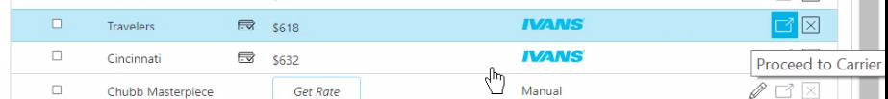
2. Click Mark as Sold; complete the “Accept Quotes” screen

1. Add the PR/BR commission information under the Pr/Br Commissions tab.

1. Once the Accept Quote screen is completed, click the **Accept** (bottom right). Epic will enter this quote as a “submitted” policy in the Policy area of the client’s account.
2. An MQS activity will generate; close this activity as successful. Continue to use the RPQS activity until the policy has downloaded and policy checking has been completed
3. If the “Change Client Type” screen appears, click YES to update the policy to contracted and the prospect to client.
4. All quotes will be stored for history. The quote selected will now be marked as SOLD.
5. Download will update the service summary stage to “Issued” on the policy that was created via Quotes.

**NOTE:** If none of the quotes were accepted, close the NPQS Unsuccessful and selected the appropriate reason

### Quoting via Live Fill

1. To quote with carriers not available via one-click, click the “Start Website Quote” button. A screenshot of a computer

   Description automatically generated
2. Click the drop down to see a list of all appointed carriers; select a carrier

1. This will launch you into the carrier’s quoting portal
2. Run quotes as normal on the carrier’s portal
3. Epic will pre-fill information that was entered in QUOTES. Information in data fields showing green or yellow came from Epic Quotes. Anything in white is a carrier-specific question.
4. Change any prefilled data, if needed.
5. Once the quote is processed, save it in the Quote Results page to get a side-by-side comparison with other One-Click quotes.
6. Once finished with one carrier, close out of it, then select the next carrier from the drop-down list, repeat the process
7. To save the quote, click the “Save Quote” button at the top right 
8. Enter information, then click Save Quote.

1. The quote will be saved on the “Quote Results” page, showing quote type as “Website”

1. Click the boxes in the Compare column of the carriers/rates to include (including the website quotes) then click the Compare column header to see results.

### One-Click Carrier Quoting (Remarket Existing Policy)

1. If using Renewals Manager, highlight the expiring policy from the Renewal Manager area then click the Get Quote button.
2. If not, locate and select the client
3. Click Quotes in the left panel

1. Cancel out of the new quotes screen. Instead click the link to “Remarket Existing Policy” at the top right

1. Select the policy to remarket
2. Complete the required information on Remarket Quote Information screen and select ADD

1. If you are licensed for the data prefill program, this screen will appear

1. To view the information that came in from the existing policy, click the Summary tab  
   A screenshot of a computer

   Description automatically generated
2. Go through each tab to see if there are any missing required fields.
3. Missing required fields will be in red, completed required fields will be in green. Enter the missing required information.
4. If another quote is needed for the insured, click the Add Quote button

1. When all the fields have been completed, select Get Quotes

1. IVANS One-Click or Instant Rate Quotes display automatically
2. Highlight a quote to view details.
3. To compare several quotes, check the compare boxes, then click the Compare column header.
4. When a carrier is decided upon, go to the carrier website to order the coverage to be bound.
5. Mark as Sold; an MQS activity will generate; close this activity as successful. Continue to use the RPQS activity until the policy has downloaded and policy checking has been completed
6. Complete the Accept Quote screen, including information in the Pr/Br Commissions tab, then click the Accept button at the bottom right.
7. All the carriers and their quotes are retained for historical purposes.
8. Within the Policy area, note that the expiring policy renewed with the carrier that was selected for binding and the service summary stage has been marked as Submitted. The download will update the stage to Issued.

**NOTE:** If none of the quotes were accepted, close the RPQS Unsuccessful and selected the appropriate reason

**JA.2 Marketing Module Extra Lite (New or Renewal Business**

**Add Master Marketing Submission**

1. Click **Policies** area from the left Navigation Panel of the Client’s account
2. Change policy view from **Current** to **Marketed**



1. Click the **ADD** button (+)
2. Enter a name for the Submission (Name: 23-24 Master Submission)
3. Enter required information (Department & type of business)
4. Add policies to the submission by clicking the **ADD** button under Policies to Market
5. **Add New Line**—Create new policy(ies) for marketing or **Use Existing Line** when remarketing renewal and select from the current policies list
6. Click **DETAIL**
7. Close the **AMMK** Activity - Finish
8. Enter policy detail by clicking each line in the navigation panel and completing each of the screens to fill in detail in the ACORD apps (be sure to add detail to the ACORD first)
9. Click on Submission Detail area from the Navigation Panel and click the **ATTACHMENTS** Tab and drag & drop all attachments to be included in the submission

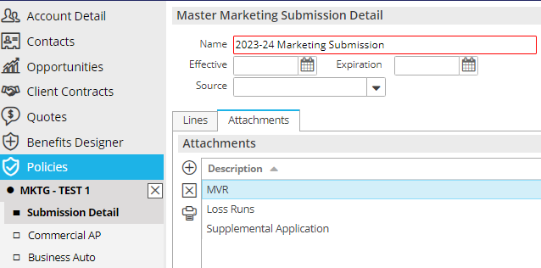

1. When finished, close Submission from the navigation panel (X)

**Add QNEW (New Business) or QREW (Renewal) Activity**

1. From the **Policies Marketed** list view, highlight the Master Submission
2. Click the **NEW** button at the top in the blue bar; select **Activity** (or press F9)
3. Click **Continue**
4. Code = **QNEW or QREW**
5. Leave OPEN; add notes
6. Click **Finish**

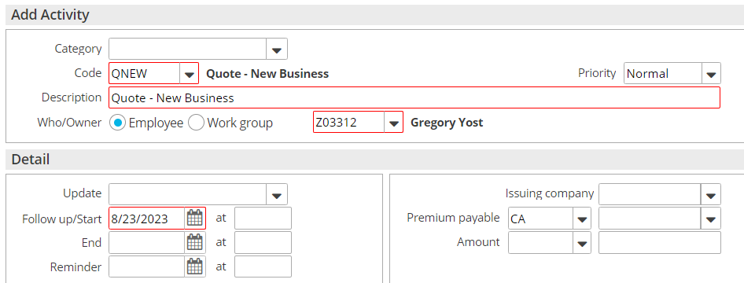

**Send Applications to Carriers**

***Save & Submit ACORD Applications***

1. Right click on the Master Marketing Submission created above
2. Select **Review Application**
3. Click the **Organization Contact** tab and verify/update the agency address
4. Click the **Distribution** tab
5. Under **Delivery Options** select **“Attach Without Distributing”**
6. Click **Finish**
7. With the submission highlighted, click **ACCESS >** **Attachments**, **right click** on the Submission ACORD, and select **Send Via Email** if emailing to the underwriter. Attach email to **QNEW/QREW**
8. If quoting online, add notes to the Open **QNEW** or **QREW** Activity.

***Attach quote-related documents to QNEW or QREW***

Be sure to attach all emails, documents, applications, etc. to **the QNEW or QREW activity**

1. Drag & drop onto the **QNEW** **or QREW** activity
2. Select the **Marketing** Folder
3. Click **Finish** on the **Attach to** screen

**Carrier Responses Received**

1. Record carrier responses by adding NOTES in the **QNEW or QREW** activity.
   1. Right click on the **QNEW** **or QREW** activity
   2. Select Add Note
   3. Enter detailed note



1. Drag & Drop Carrier emails to the **QNEW or QREW** Activity

**Carrier Selected for Binding**

1. When a carrier is selected for **binding**, close the corresponding **QNEW** **or QREW** activity as **Successful** and add notes

***Please note, if no carrier is selected for Binding, close the corresponding QNEW or QREW as Unsuccessful and add notes. No further steps needed.***

***Move Binding Carrier Submission to Current Policies***

Follow these steps in order:

1. Right click the Master Submission and select **Create Carrier Submission**
   1. Premium Payable = select the binding carrier
   2. Submission Status = Completed
   3. Click **Finish**
2. Right click the Master Submission and select **Update Stage to Entered/Submitted**

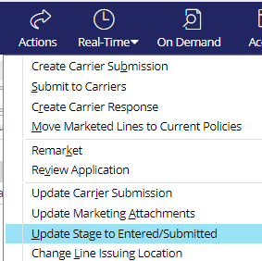

* + Click **Finish**

1. Right click the submission and select **Create Carrier Response**
   * Description = Quoted / Bound
   * Date Received = current date
   * Carrier Response = Quote
   * Enter Response Line Premium, carrier commission rate and click **Calculate**
   * Add Issuing company if known
   * Click **Finish**

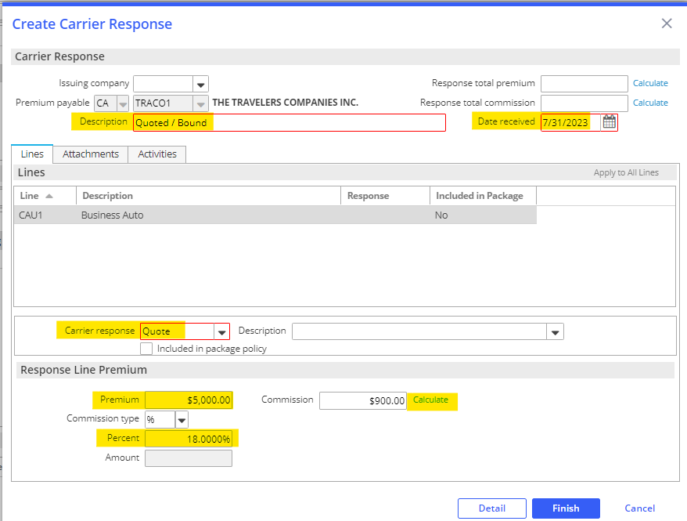

* + On the popup, select **Yes** Perform Action and select **Move Marketed Lines to Current Policies**

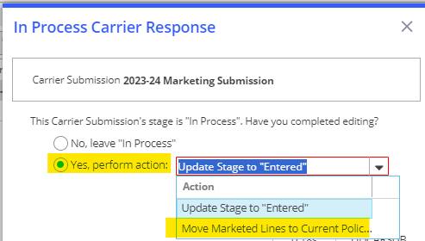

***Policies Tab****:*

1. Select **Add new Policy**
2. Enter Policy Line, Description, Effective & Expiration Dates
3. Update Stage to: Submitted or In Process if policy detail edits are needed
4. Select Contracted policy

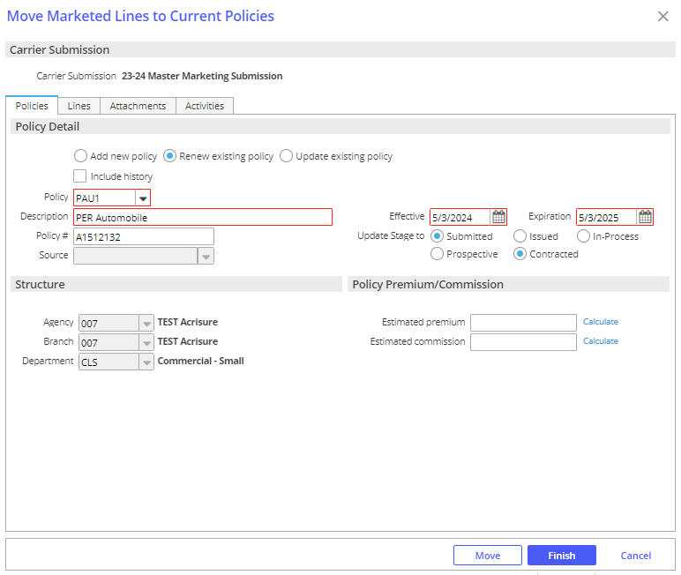

***Lines Tab:***

1. Select the lines to add to the new policy, renewal, or existing policy
2. Select **Add to this policy** - Adds the line to the policy added under the Policies tab

* Keep in mind, the choices are made here affect only the highlighted line
* Use **Apply to All Lines** if the choices apply to all lines and not just the highlighted line.

1. Under the LINE tab, select Status = NEW; enter Issuing Co (writing co); enter carrier commission rate

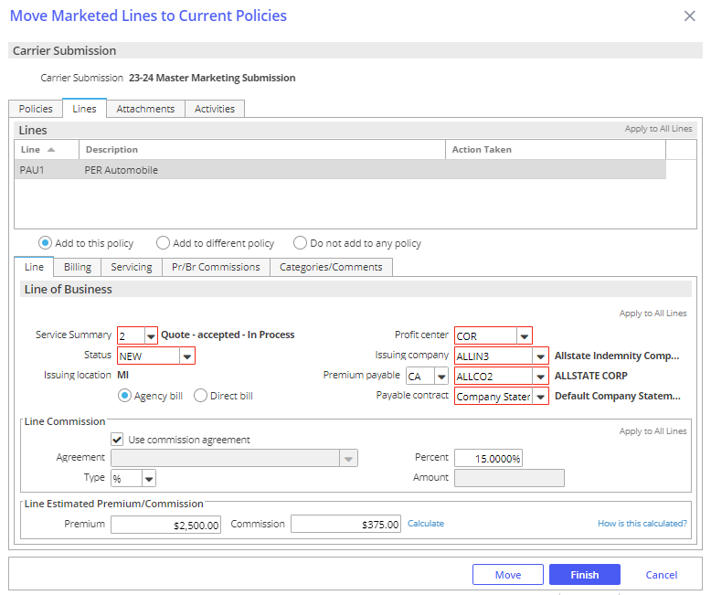

1. Click the **SERVICING** tab – verify the employees in each servicing role

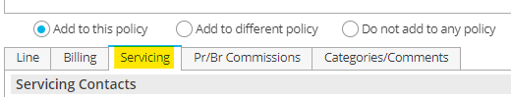

1. Click the **PR/BR COMMISSIONS** tab

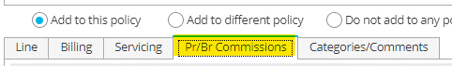

* + Click the **ADD** button to add the producer who will be paid commission on this policy if applicable
  + Producer Commission will default
  + Production credit should be 100%

1. When finished, click **MOVE**

* Update Submission status to Completed; click **Finish**

1. **BND1** Activity – Bind Policy via Master Marketing
   * Leave open for receipt of policy
   * Add Notes
2. Change Policy view from MARKETED to CURRENT

**Policy Received from Carrier**

1. Drag & Drop the policy dec to the **BND1** in the client’s account
2. Issue the Policy in Epic:
   * Highlight the policy
   * Click **ACTIONS > Issue/Not Issue Policy** and **Issue**
   * Verify Policy #, Effective/Expiration Dates, Estimated Premium and Policy Status (NEW)
   * Click the **Close Open Activities** tab and close the open **BND1** activity as Successful and add final note
   * Click **FINISH**

## JA.3 Proofs of Insurance

### EPIC Auto ID Cards

1. Select Policy
2. **ACTIONS > Issue Auto ID Card**
3. Highlight the appropriate vehicle—make sure there’s a Y under the Issue Column or Click Select to Issue if not
4. Click the Distribution Tab
5. Select Contact (use magnifying glass to locate)
6. Select Via (Print, Email, Fax) and enter additional details
7. Click **Finish**—AUID Activity defaults closed

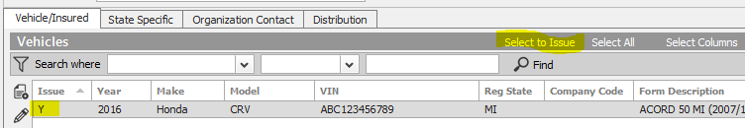

### EPIC Evidence of Property Insurance

#### Add New Evidence

1. Locate Account
2. Click the **NEW** button—Proofs > Evidence
3. Select the appropriate ACORD form; enter a Title
4. Under Type, select appropriate policy and service summary row
5. Click **Detail**
6. Click each section and enter details
7. When completed, click **ACTIONS** > **Issue Evidence**
8. Click the Additional Interest Distribution Tab
   * Select Contact (use magnifying glass to locate)
   * Select Via (Print, Email, Fax) and enter additional details
   * Click **Finish**
9. Click the X in the Navigation Panel to close the EPI

#### Renew Evidence

* + - 1. Locate Account
      2. Click Proofs of Insurance from the Navigation Panel
      3. Select Evidence
      4. Highlight the appropriate EPI
      5. Click **ACTIONS** > **Renew Evidence**
  + Select the renewal policy and service summary row
  + Select the lines of business to include
  + Check the defaults to include
  + Click **Detail**
    - 1. **Activity REVI** defaults closed—add notes, click Finish

#### Issue Single / New Additional Interest

* + - * 1. Locate Account
        2. Click Proofs of Insurance and edit appropriate EPI
        3. Highlight the additional interest—click the **ADD** button to add new AI and detail
        4. Click **ACTIONS > Issue Singe Additional Interest**
        5. Uncheck Insured if not needed. Verify AI distribution.
        6. Click **Finish**

## JA.4 Renewal Manager

### Renewal Stages

***Details in the Renewals Manager view are related to the expiring policy.***

|  |  |
| --- | --- |
| **Stage Description** | **How it functions** |
| **Renewal Not Started** | Tied to the Event: **Policy Created** (display policies with this stage in the RM "**0**" days after expiration) |
| **Pre-Renewal In-Process** | Manual - (display policies with this stage in the RM "**30**" days after expiration) |
| **Submitted For Quote** | Manual - (display policies with this stage in the RM "**30**" days after expiration) |
| **Quote Received** | Manual - (display policies with this stage in the RM to "**30**" days after expiration) |
| **Proposed** | Manual - (display policies with this stage in the RM to "**30**" days after expiration) |
| **Renewal In-Process** | Tied to the event: **Policy Renewed** (display policies with this stage in the RM "**30**" days after expiration) |
| **Renewed** | Manual - (display policies with this stage in the RM "**0**" days after expiration) |
| **Did Not Renew** | Tied to the event: **Policy Cancelled** (display policies with this stage in the RM "**0**" days after expiration) |

### Renewal Events

#### Policy Created

This Event is responsible for a new policy as well as a renewed policy to be given the Stage “Renewal Not Started.” This Stage begins the renewal effort. Policies coming up for renewal will show in the RM, in advance of the renewal date with the Stage “Renewal Not Started,” according to the time frame assigned to the policy type.

* 120 days for commercial lines policy types
* 60 days for personal lines policy types
* 90 days for employee benefits policy types

#### Policy Renewed

This Event is tied to the Actions>Renew process. When the expiring policy (the current term…the policy currently being worked for renewal) is renewed (via Actions>Renew), the expiring policy (i.e., the current term… the policy currently being worked for renewal) will be given the Stage Renewal In-Process. The renewed policy (i.e., the policy created through the Actions>Renew process) will not show in the RM but will show in the Policy list view (e.g., Policies – Current/Renewed). The renewed policy will be given the Stage “Renewal Not Started.” This Stage should remain as is until ready to work on the policy renewal the following year. The renewed policy (i.e., the one created via Actions>Renew) will need to be Issued as normal. The Stage given to the expiring policy (i.e., the current term… the policy currently being worked for renewal) will need to be changed, by the user, to Renewed once the renewal policy has been Issued. This Stage “Renewed” will be the final Stage given to the expiring policy in the RM. An expiring policy with the Stage “Renewed” will drop from the RM view on the expiration day.

#### Policy Cancelled

This Event is tied to the Actions>Cancel>Issued process. The Stage shown on a policy cancelled via the Actions>Cancel>Issued process will be Did Not Renew. Note: if the policy is reinstated, the Stage will automatically revert to the Stage it was assigned to before it was cancelled.

### Renewal Manager Workflows

#### View Renewals

1. From **HOME** screen select **Renewals Manager** from Navigation Bar

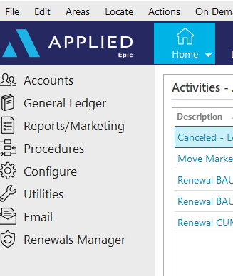

1. Assigned Servicers accounts will be displayed with a **Renewal Not Started** Renewal Stage

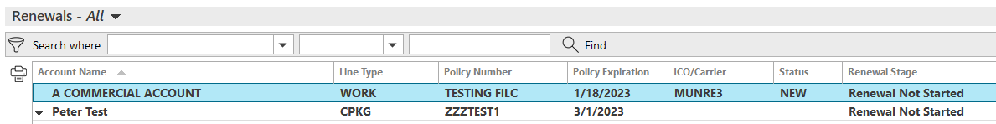

* **Personal Lines**: 60 Days prior to expiration
* **Commercial Lines**: 120 Days prior to expiration
* **Employee Benefits**: 90 Days prior to expiration

1. Click once on renewal to select:



* **Go to Policy** – Moves directly into the policy under the client’s account
* **Renew** – Starts the renewal process from the client’s account
* **Marketing Submission** – Starts a marketing submission from the client’s account
* **Update Renewal Stage** – Allows for manual update to the renewal stage
* **Market Appetite** – Launches IVANS Market Appetite with list of possible markets

#### Renew Policy

1. Select **Renew** then refer to the **Renewal Process**/**Non-Downloaded Policies**section in the Workflows Document



1. Once renewal is started, the Renewal Stage will change to **Renewal in Process**
2. Manually update the stage as needed:

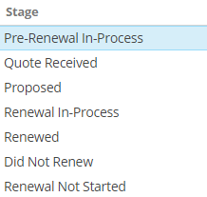

#### Marketing Submission

1. Select **Marketing Submission** then refer to the **Marketing Module** section in the Workflows Document



1. The Renewal Stage will NOT automatically update while working through the Marketing Module. The Renewal Stage must be updated manually by selecting **Update Renewal Stage.**



#### Cancelled/ Non-Renewed Policies

**Cancelled Policies:**

1. Refer to **Cancellations** section within the Workflows Document
2. Once **Cancellation** has been issued, the Renewals Manager Stage will automatically be updated to **DID NOT RENEW** and will drop off the Renewals Manger list

**Non-Renewed policies:**

1. Refer to **Policy Not Renewed** section of the Workflows Document
2. The Renewal Stage will NOT automatically update after the Policy has been manually Non-Renewed. Update the Renewal Stage by selecting **DID NOT RENEW** from **Update Renewal Stage**. This policy will NOT drop off the Renewals Manager list, but will stay for one day AFTER expiration

## JA.5 DocuSign Integration

**From Attachments in the Client’s account**:

1. Right-click the attachment and select **Send to eSignature**

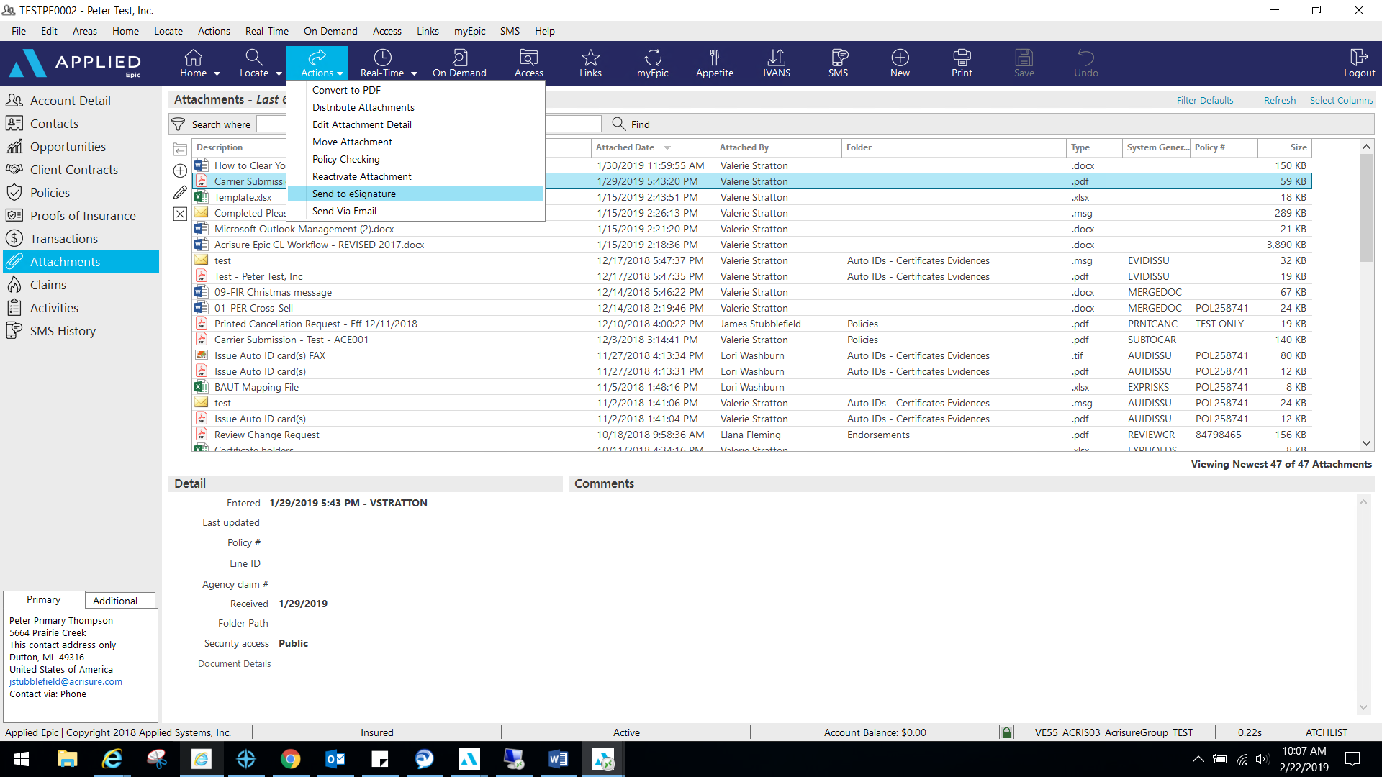

1. 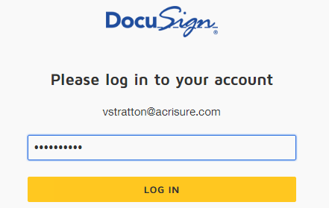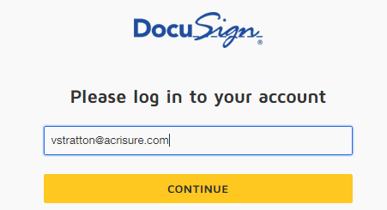Log into **DocuSign** using your email address and password.
2. Allow DocuSign permission to integrate with Epic.

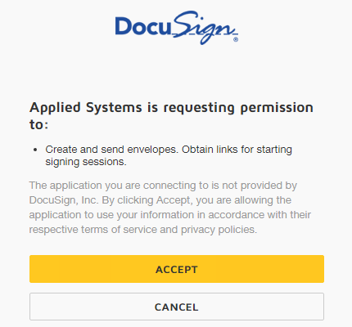

1. Select an Epic Contact; click the TO button

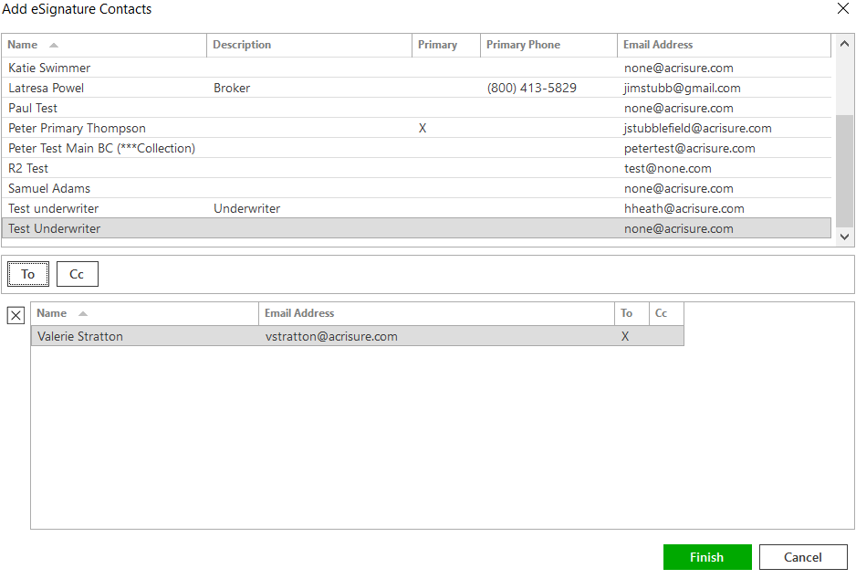

1. Please wait while Epic directs the document to DocuSign for signatures fields.
2. Add appropriate fields for signature, date, text, etc. by dragging and dropping onto the document.

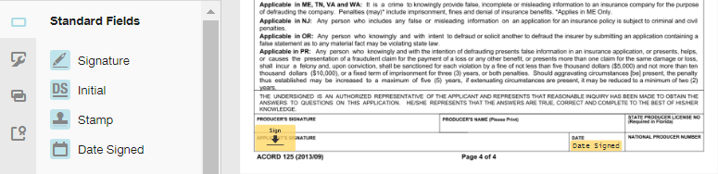

1. If using a template, remove the extra recipient. Actions>Edit Recipient

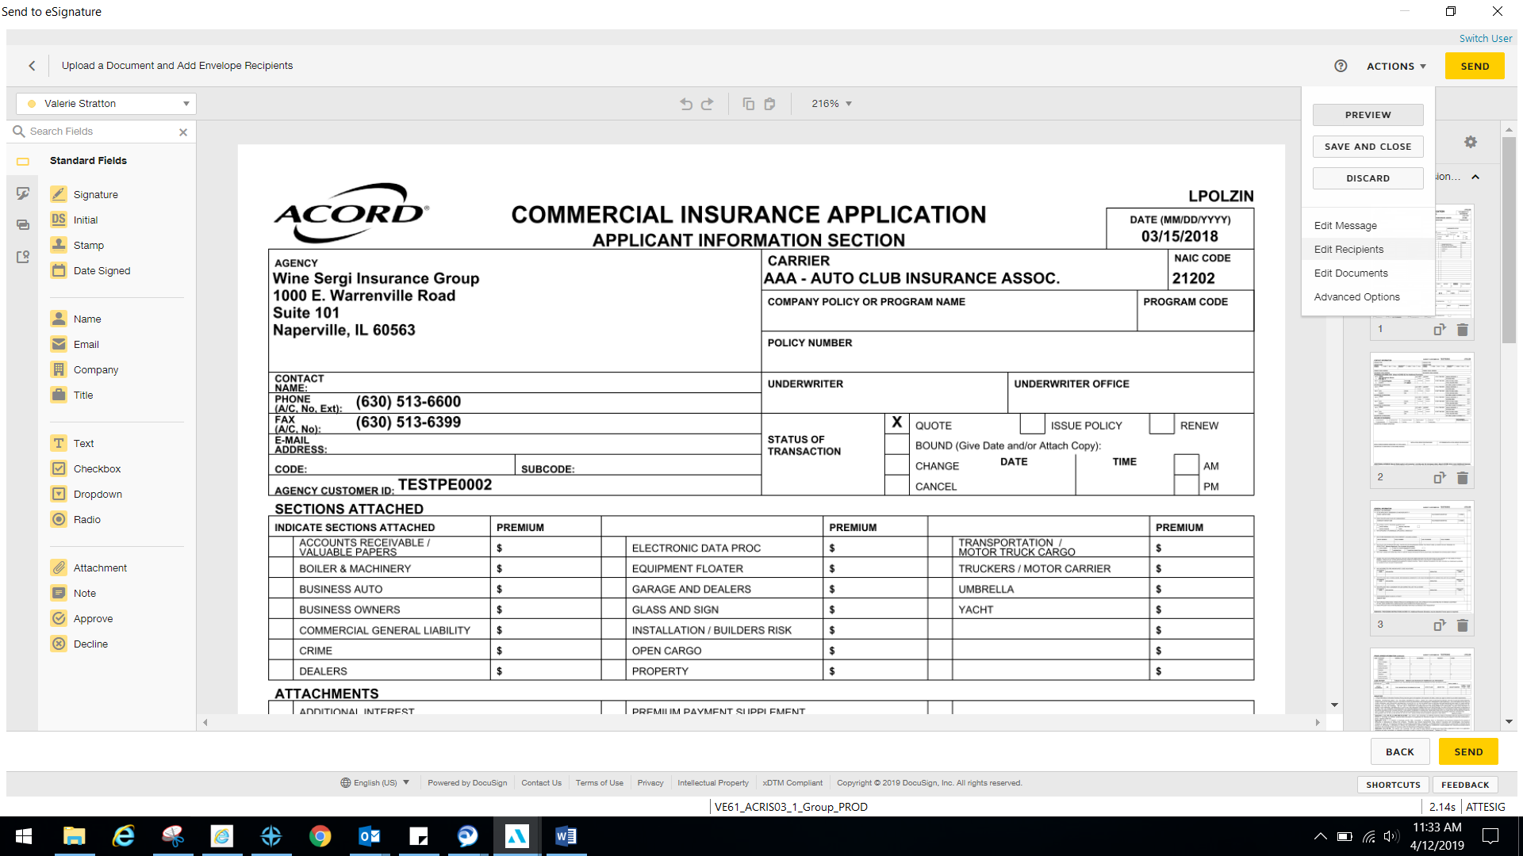

1. Once finished, select Actions>Edit Message.

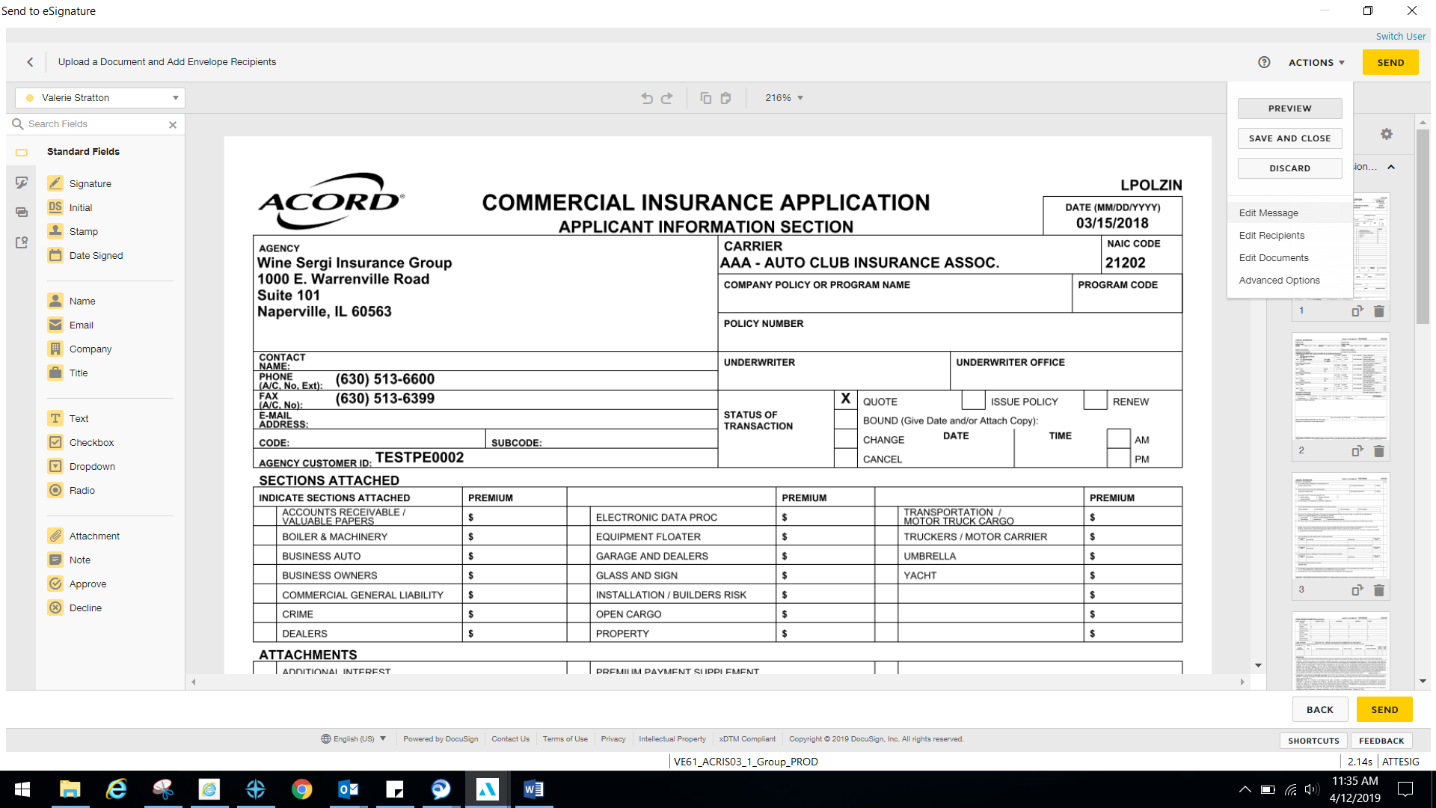

1. Edit the email subject line and personalized message to client and select Done.

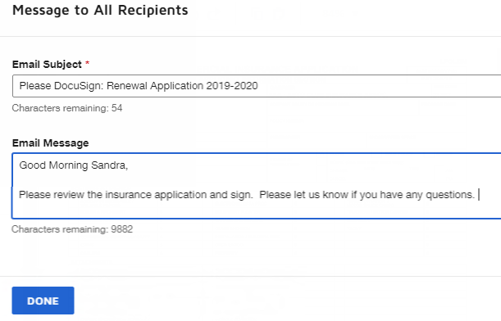

1. Select Send in the top right or bottom right corner when finished.

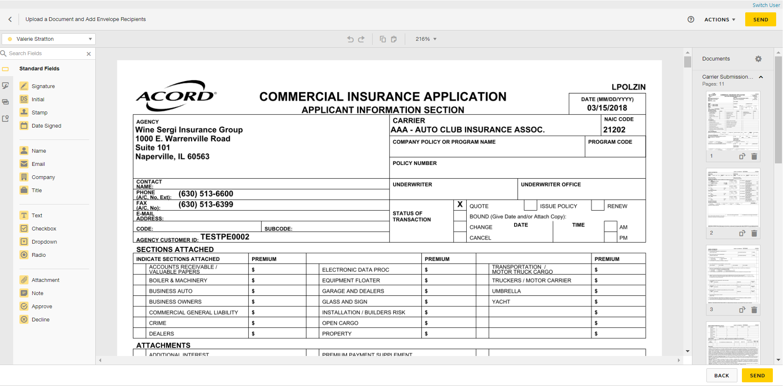

1. DocuSign will redirect you to sign into your account to manage your envelopes. Close out when finished.
2. **ESIG** will be the automatic activity generated once finished and will automatically remain open for follow up. Close **ESIG** as successful if there is another open activity related to this process.

## JA.6 CSR24 – Set Up Portal User from EPIC Contacts

To set up a Contact as a Portal User:

1. Locate the Client’s Account in Epic
2. Click Contacts
3. Click Create Portal Account button

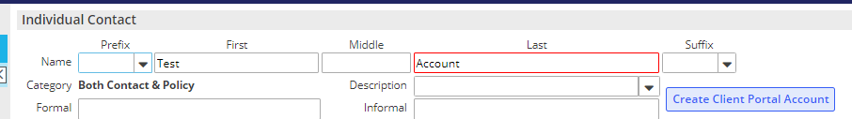

1. Click the Contact who should be set up as the Portal User
2. In the top blue options bar, click Portal

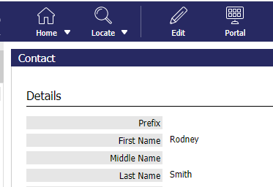

1. Username defaults to contact’s email address; change if necessary
2. Click the blue “Change Password” link and enter a temporary password



1. Check the box to Require User to change password on next login

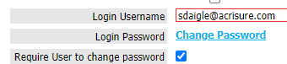

1. Select a Start Page to assign to this client contact (your agency’s start page(s) will reflect in the dropdown list)
2. At the bottom of the screen, click this link

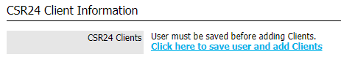

1. At the top of the screen, click the SAVE button



1. Notice in the Contacts area, the Portal user box will be checked for the contact just added.

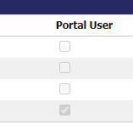

1. Repeat the process for any contact listed as needed.

## JA.7 CSR24 – Making Attachments Client Accessible

1. LOCATE Client
2. Click Attachments from the left navigation panel
3. Right click on the attachment to give your client access, and select **Edit Attachment Detail**

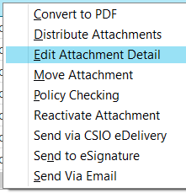

1. In the Attachment Details window:
   * Update the description as needed
   * Select the appropriate folder (select a folder only from this list) (CONFIRM SCREENSHOT BELOW IS CORRECT WITH PLATFORM FOLDER STRUCTURE)
   * Check the **Client Accessible** box
   * 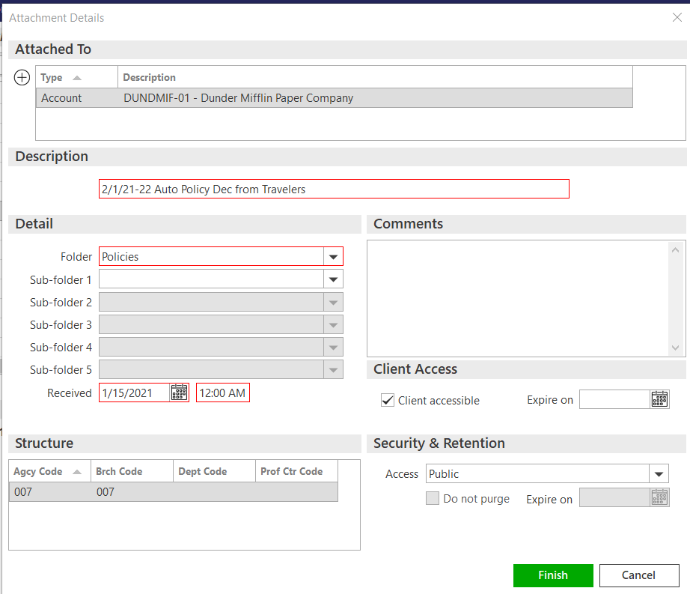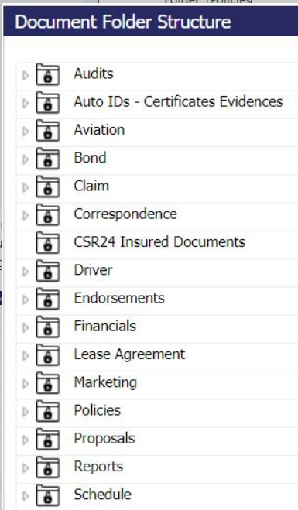Click **FINISH**

## JA.8 Import and Export Risks

|  |
| --- |
| Import/Export can be performed for the following:   * Locations * Drivers * Named Insureds * Vehicles * Scheduled Equipment |

### STEP 1: Create a Mapping File

|  |
| --- |
| A correctly formatted mapping file is needed to ensure that data imports into the correct fields in Epic. Before importing, create a blank mapping file (spreadsheet)   1. Highlight appropriate policy 2. Click ACTIONS > Export Risks 3. Select Type of Import – drivers, vehicles, etc. 4. Select Mapping File 5. Enter a file name 6. Check “Disable Delivery Options” 7. Check “Send as Blank Template”   A screenshot of a computer  Description automatically generated   1. Click Continue 2. Click Export; Click YES 3. Click Attachments and locate the mapping file. The mapping file can then be used to paste details into a file for the initial import, proceed to next step. |

### STEP 2: Enter data on the Mapping File

|  |
| --- |
| **Template file MUST remain as is. Do not delete any columns or the Import will not work.**   1. Copy and paste the information in each column. If there is no data for a particular column, leave it blank. 2. Click File > Save As and rename the Import File saving it to your Desktop |

### Exporting Risks out of Epic

|  |
| --- |
| For risks that are already in Epic, use the export risk function to generate a spreadsheet that the client can update at renewal. Those risks can then be imported back into Epic.     1. Highlight appropriate policy 2. Click ACTIONS > Export Risks 3. Select Type of Import – drivers, vehicles, etc. 4. Select Mapping File 5. Enter a file name – ex. 2024 Driver List 6. Check “Disable Delivery Options” or complete the email information to deliver out of Epic to the client 7. Click Continue 8. The next screen will show all risks to be exported, if that list looks correct, click Export > then click YES 9. The file will be in the attachments. Email to client for review and update. Completed spreadsheet should be saved on your desktop for importing into Epic |

### Importing Risks into Epic

|  |
| --- |
| Policy status MUST be “In Process” in order for Import Risks to work. If the policy is not “In Process”, click **ACTIONS** > Endorse/Revise Existing Lines and choose the **CHGI** (Internal Policy Change) activity code. After the Import is complete, **ACTIONS** > Issue/Not Issue Endorsement and select Issue.   1. Highlight appropriate policy 2. Click ACTIONS > Import Risks 3. Click the ADD button to add the source file 4. Select Risk Type 5. Select an Importing Option:    1. Import & Update – items with no match will be added    2. Import & Replace – imported list will replace ALL existing items. Coverage information will be lost    3. Import, Update & Remove – items with no match will have the option to be deleted from the policy 6. Select File to Import – click the magnifying glass to locate the file you created in Step 2. 7. Choose “Existing File” if the file is located outside of Epic (i.e., Desktop); click Continue 8. Browse, select file, click Open 9. Change Description if needed 10. Click **Finish** 11. Click **PROCESS**   A screenshot of a computer  Description automatically generated   1. A close up of a screen     Description automatically generatedPay attention to the **STATUS**; click Refresh. 2. When status = **Processed**, click CREATE 3. Pay attention to the STATUS; click Refresh 4. When status = **Created**, click PREVIEW 5. Import list will display 6. Click **IMPORT** 7. Click **YES** 8. Pay attention to Status; click Refresh 9. When import file disappears, the import was successful 10. Close window (red X top right) 11. Double click policy to view imported data 12. Close policy in Navigation Panel (gray X) 13. Select “Yes Perform Action” and choose “Issue/Not Issue Endorsement” 14. Click Finish |

### Import Errors

|  |
| --- |
| Sometimes data does not import correctly. When this happens, the following messages appears. Follow the steps to review and update the errors.  A screenshot of a computer error  Description automatically generated  Epic will save a separate Excel file containing all the rows that failed.   1. Locate the Error File in Attachments 2. Fix the issues 3. File > Save As and save the updated file to your Desktop 4. Run the Import again |

## JA.9 Creating a Proposal or Summary in Epic

### General Information

|  |
| --- |
| Epic has been configured with templates to allow users to generate Platform branded Proposal and Summary that can be used to present to clients when marketing coverage for new or renewal business. The Summary template is accessed using On Demand>Proposal – Do not use On Demand>Summary of Insurance.    **The following are highlights and pointers to consider:**   * The same proposal group works from either the Current/Future lines or the Marketed lines (at the carrier response stage) * Each line of business is configured to pull the following four (4) areas from the Epic policy details into the Line of Business page on the Proposal:   + Additional Coverages   + Forms & Endorsements   + Remarks (only when the Print on form is checked)   + Additional Interest * When using the Summary Group, users will have to associate the Line of business to both the Premium Summary pages and the Detail pages for each selected policy. This will ensure that the policies will appear on the premium summary page as well as the policy detail pages.      * Remember to enable Macros when the Word document generates as this is how the data merges into the document. * The overall formatting of each page of the Proposal and Summary templates has been designed to meet the legal specifications of Acrisure and to meet general needs of most of the users. The word document will need to be reviewed carefully as some data may need to be manually updated. Tables and data fields with no information should be updated or deleted and spacing should be adjusted to provide a professional look and feel. |

### How to Generate a Proposal

|  |
| --- |
| 1. Within the Client Account navigate to the Policies tab.  2. Click on a policy (or package header)   * 1. If creating a proposal for Marketed, change the view from Current/Renew to Marketed and then select the Submission.   3. On the Option Bar/Menu (top navy bar) click On Demand>Proposal.  **Refer to the screen shot below and the corresponding numbers with the following steps:**    See Notes  1. Add/Remove the policies that will need to be included in the proposal.   * 1. Click on the ADD button and choose from either:   2. the available current/renewed policies, if generating from the current/renew policies view   3. the available lines being in the marketing submission, if generating from the marketing area   * You do not need to reposition the LOBs on the top half of the proposal box.  2. Pick the Proposal Group. The NJ Platform has the following options and each one has preselected pages within the group. Choose the option that best suits your needs.   * 1. 1. Acrisure Standard Proposal   2. 1. CL Acrisure Summary of Insurance   3. 1. PL Acrisure Summary of Insurance   3. The Proposal Templates/Proposal Documents box will display all the preselected pages available based on the selected Proposal Group. This list must be reviewed, and pages deleted or rearranged based on guidelines determined by your leadership.   * 1. You must have a cover page and it must be in the top position   2. Associate a Line of Business to the Location Summary page to pull premises data   4. Individual Contacts are from the Account Contacts tab and will default with the Primary contact. added here will pull through to the Authorized Persons page.  **Notes:**  1. Before pressing Finish, you can add/move/delete pages, using the buttons on the left.  2. If you have multiple LOB of the same type, extras will drop to the bottom of the list. Be sure to reorder them before pressing Finish.  3. The premium summary page must appear after all the LOBs. Note: after merging, it can be moved.  4. LOBs without an associated Line will be suppressed by default. Uncheck the box next to Suppress blank templates to bring in the page even if there is not a LOB connected yet (e.g. you want to offer Cyber but it is not included on your account yet). |